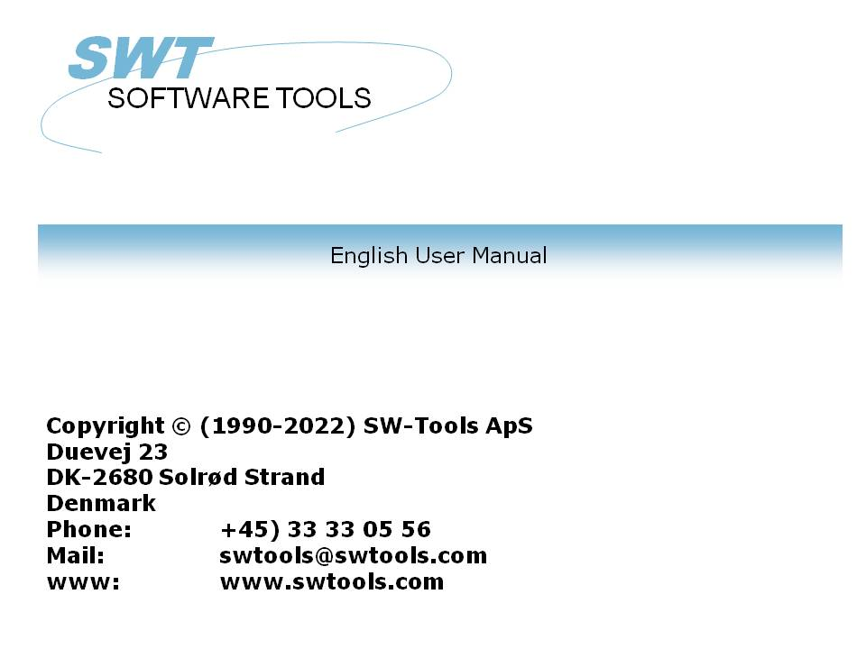

Setup Wizard - Concorde C5/XAL

22/11/01 / 2022-09-01 008.384

Contents
Contents 2
1. The Setup Wizard 3
2. Step 1 - Interface 4
2.1. Requirements 5
3. Step 2 - Database 6
3.1. Database Name 7
3.2. DBD File 8
4. Step 3 - Data-Dictionary 9
5. Finnished 10
Figure list 11
Index 12

1. The Setup Wizard

The Setup Wizard provides an easy way to setup the components required for working with SW-Tools TRIO for reports, queries and data entry and for SW-Tools ODBC driver.
The wizard will guide you through the following:
- Selecting an interface (Required)
- Setup of the interface fields (Required)
- Location of the sub system (Required)
If you require to amend an interface setup by this Wizard please refer to the 'Data-Dictionary' manual.

2. Step 1 - Interface

When the Setup Wizard is started you are required to select an interface. Normally you will only have one but several may be listed according to the interfaces known to the SW-Tools products.
You need to select the following interface as shown in this figure:

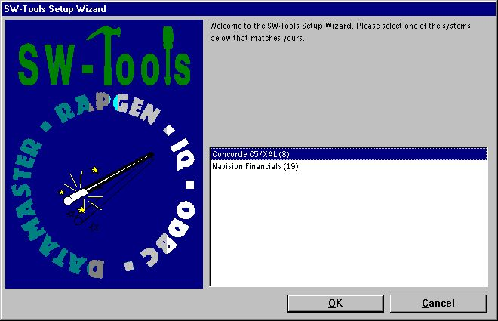

1. Selecting the Concorde C5/XAL interface

2.1. Requirements
There are some requirements which must be present in order for the SW-Tools products to access Concorde.
- Access to server where Concorde is installed through a network drive

3. Step 2 - Database

This chapter describes how to enter the fields required to setup access to Concorde. The fields are presented in a dialog looking like this:

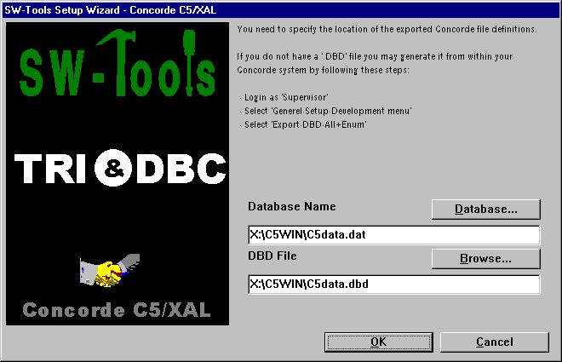

2. Setup access to Concorde dialog

3.1. Database Name
Enter the name of the database you want to connect to. You can see a list of available databases by selecting the field "Database...". Browse to the relevant folder, select the database file name, and then select Open to copy the name to the field.

3.2. DBD File
Enter the name of the DBD file you want to connect to. You can see a list of available DBD files by selecting the field "Browse...". Browse to the relevant folder, select the DBD file name, and then select Open to copy the name to the field.

4. Step 3 - Data-Dictionary

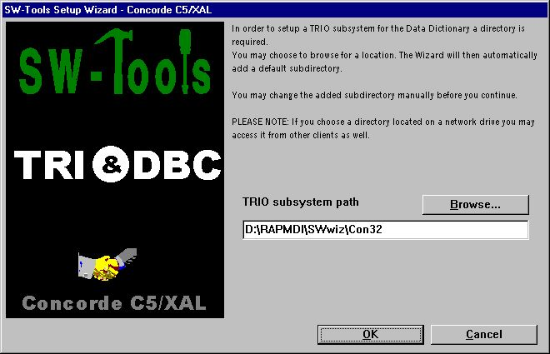

3. TRIO subsystem path

5. Finnished

When the wizard has completed it will list what has been setup:

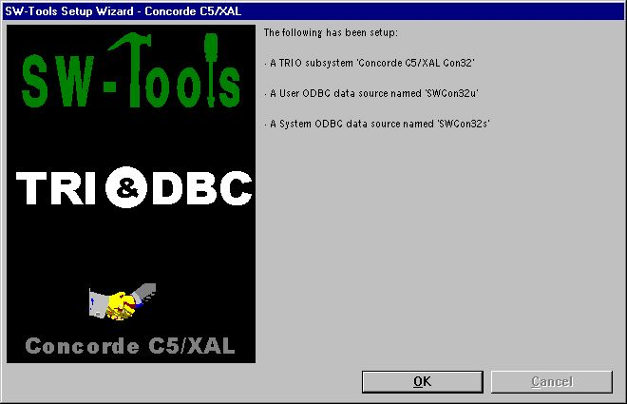

4. What has been setup
You may now work with SW-Tools TRIO and ODBC.

Figure list
1. Selecting the Concorde C5/XAL interface 4
2. Setup access to Concorde dialog 6
3. TRIO subsystem path 9
4. What has been setup 10

Index

C
Concorde 1;4;5;6;11
D
Database 6;7
Data-Dictionary 3;9
DBD 8
I
Interface 4
O
ODBC 3;10

