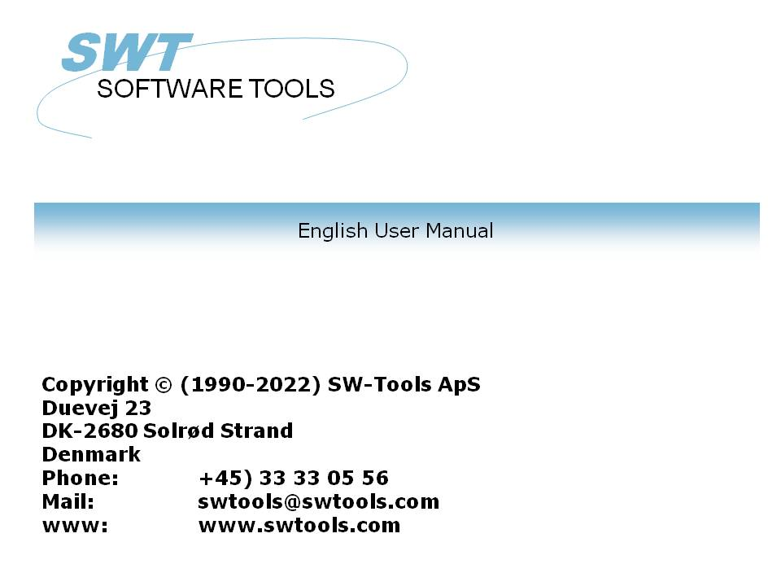

TRIO Release Information (007.000)

22/11/01 / 2022-09-01 008.384

Contents
Contents 2
1. Introduction 5
1.1. TRIO 32 Bit release 6
1.2. Charts 7
1.3. OLE 2.0 support 8
1.4. USER administation 9
1.4.1. Report start statistics and jobqueues 10
2. Installation 11
2.1. Running TRIO from the CD 12
2.2. Selecting TRIO components to be installed 13
2.2.1. Installing a UNIX server using FTP 14
2.3. Server programs 15
2.4. Version number 16
2.5. Licensing 17
3. The Data Dictionary 18
3.1. Number of fields increased to 999 19
3.2. Floating decimals 20
3.3. Thousand editing 21
3.4. Index key definitions, LOGICAL index 22
3.4.1. Directory 00 recordnumber reading 23
3.4.1.1. ACCESS using SWODBC on non-indexed files 24
3.4.2. Suppressing IQ search on specific index (*xx) 25
3.4.3. Suppressing index update for a specific index (-xx) 26
3.4.4. Creating a pseudoindex for a file (+xx) 27
3.4.5. Index example 28
3.4.6. Key options, Descending index 29
3.5. File connection definitions 30
3.5.1. Multiple connections to the same file using upper/lower case 31
3.5.2. Multiple connections to the same file using logical index 32
3.5.3. Forcing connections by READ 33
3.6. Packtypes for fields 34
3.6.1. Secondary packtypes 35
3.6.1.1. Secondary packtype parameters 36
3.6.1.2. Default secondary packing for BASIC dates 37
4. Year 2000 38
4.1. Preferences 39
4.1.1. Date output format 40
4.1.2. Internal date calculation format 41
4.2. Server and file update 42
4.3. Date sorting 43
4.4. DOS dates 44
4.5. Date function updates 45
4.6. Year 2001 problem 46
4.7. Year 2005 problem 47
4.8. Year 2010 problem 48
4.9. Year 2100 problem 49
4.10. Date input validation 50
4.10.1. IQ selection date input 51
4.10.2. CHAIN function masked date input 52
5. Database interface drivers 53
5.1. BASIC Interfaces 54
5.2. NETBASIC using CTRAS functions 55
5.3. Quattro interface using CTRAS 56
5.4. Quattro interface using 32 Bit FTP 57
5.4.1. Working offline with the Quattro files 58
5.4.2. File definitions 59
5.4.3. XBasic and other interfaces using 32 Bit FTP 60
5.5. GLOBAL 3000 Speedbase and Global 2000 ISAM/DMAM 61
5.6. NAVISION Financials 62
5.6.1. Install Navision Financials and C/FRONT 63
5.6.2. Install and configure the Navision Financials interface 64
5.6.3. Import of table definitions 65
5.7. CONCORDE C5/XAL 66
5.7.1. Exporting the Concorde file definitions 67
5.7.2. Install and configure interface to Concorde 68
5.7.3. Import of table definitions 69
5.8. Btrieve version 5.10 and 6.15 70
5.8.1. Install and configure interface to Btrieve 71
5.8.1.1. Advanced options 72
5.8.1.1.1. Open mode 73
5.8.1.1.2. Name suffix 74
5.8.1.1.3. Name options 75
5.8.1.1.4. Parameters 76
5.9. ODBC drivers interface - Application type 77
5.9.1. Type 1 - Support of Informix Database table locks 78
5.9.2. Type 4 - Always perform ORDER BY 79
5.9.3. Type 4096 - Alpha fields may NOT be NULL 80
5.9.4. Type 8192 - ODBC Drivers with support of one connection per table only 81
5.10. ISAM database interface - Application type 82
5.10.1. Type 2 - Support of SAMSON system 83
5.11. SSV database interface 84
5.11.1. Write sortindex 85
5.11.2. Headerlength 86
5.11.3. First data record 87
5.11.4. Make indexfile > records 88
5.11.5. Write CRLF 89
5.11.6. Indexfile naming 90
5.11.7. Duplicates >= index 91
5.11.8. Read CRLF 92
5.11.9. Compression used 93
5.11.10. Initial codetable 94
5.12. Extended SSV interface 95
5.12.1. Fixed recordlength 97
5.12.2. Fixed blocklength 98
5.12.2.1. Max no. of data records 99
5.12.3. Fixed records/block 100
5.12.4. First free record 101
5.12.5. No.of free records 102
5.12.6. Next free record 103
5.12.7. Filename type 104
5.12.8. Field Pack types 105
5.12.9. Key Pack types 106
6. Printing 107
6.1. Screen printer enhancements 108
6.1.1. Saving the screen print to a file 109
6.1.1.1. SCRPRT function for IQ print recall 110
6.2. Multi Output Format printers 111
6.2.1. Printer type 112
6.3. Text printer, Printertype 1 113
6.3.1. Options 114
6.4. HTML printer, Printertype 2 115
6.4.1. HTML output of standard reports 116
6.4.2. HTML output of non-standard reports 117
6.4.3. Background, logo and browse buttons 118
6.5. RTF printer, Printertype 3 119
6.6. TXT printer, Printertype 4 120
6.7. SSV printer, Printertype 5 121
6.8. Options for printer type 2 - 5 122
6.8.1. Output to file 123
6.8.2. View output with 124
6.8.3. Definition file 125
6.9. Printing Labels 126
6.9.1. How to use in RAPGEN 127
6.10. RAPGEN start parameter 128
7. Calculations 129
7.1. Wizard function helper 130
7.2. External DLL functions 132
7.3. DIALOG function for additional input 133
7.4. PARAMS function for additional report start parameters 134
8. Subfunctions 136
8.1. DIALOG - Function for additional input 137
8.2. PARAMS - Function for additional report start parameters (RAP) 138
8.3. FTP - File Transfer Processor 139
8.4. GETINFO - Get additional program information (IQ/DM) 140
8.5. LINE - Retrieve or set the current line number (IQ/DM) 141
8.6. OBJECTGETSTRING- Get index of an objects selected item (IQ/DM) 142
8.7. PRINT(LAB= - Label function (RAP) 143
8.8. SCRPRT - Recall screen print (IQ) 144
8.9. SHOW- Enable/Disable/Show/Hide a field (IQ/DM) 145
8.10. USERINFO - Get information about user 146
Figure list 147
Index 148

1. Introduction

The release 007 of TRIO contains many improvements such as 32 Bit version, Charts, OLE, FTP, additional database interfaces, user administration and function help wizard.
For customers with maintenance contract the additional functionallity is free of charge, however upgrading to 32 Bit must be paid as is the User Administration module including report statistics and jobqueue considered as a separate application.

1.1. TRIO 32 Bit release
All modules are now available in 32 Bits versions for Windows 95 and NT. The 32 bits version will work exactly like the 16 bits versions apart from a speed improvement which has been measured to between 10 to 75 % dependent on the user program.
On many installations the requirement of servers will change as the 32 Bit Windows server may no longer be needed on NT X-Basic systems which also should reduce the overhead. Quattro customers using 16 Bit Ctras must stick to TRIO 16 bit as CTRAS will not be released for 32 Bits.

1.2. Charts
The chart functions provide the user with a very simple way to produce a chart for report just by checking this option on the total dialogbox. Also an IQ program may easily be extended with a chart.
Different chart forms are available as Bar, Pie, Line and XYZ point and a set of calculation functions are added for the advanced users who needs an extensive control of chart options.
The TRIO Charts manual desribes these functions in details.

1.3. OLE 2.0 support
Support of OLE 2.0 Object Linking and Embedding gives the user possibility of integrating other Windows applications in the report or query defined in TRIO.
For example Microsoft Word may be used when defining a customer letter and a video sequence may be played on an article query.
The interface is simple to use as the OLE object is just defined as a field in TRIO marked as OLE and placed on the report form / IQ query just like a picturefield. Display and amendment of the contents will then be carried out by the selected OLE server program. Optionally a link to an existing document may be used or an object embedded and stored within the TRIO program can be created.
The TRIO OLE manual describes these functions in details.

1.4. USER administation
By means of the User administration it is possible to restrict the set of reports / IQ programs and files which are available to the enduser. Permissions may be given as overall for a TRIO module or specified detailed for single fields in the files for read or write.
Users may be grouped together with same permissions or quite individual systems may be created for one or more users overheading some of the subsystem control used today.
The TRIO USER Administation manual describes these functions in details.

1.4.1. Report start statistics and jobqueues
A logfile with the last 100 start informations is kept for each report and displayed by report start. The parameters may be reused for next start or an average runtime statistic may be shown just by click on an entry line.
Queues of reports may be builded which may then be started just as a single report.

2. Installation

TRIO is now distributed on CD-Rom and the autorun facility has been added so installation screen will be shown automatically when the CD is mounted on a Windows 95 system.

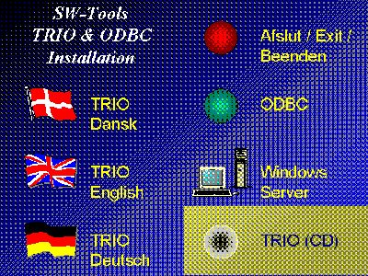

1. The CDMENU selection

2.1. Running TRIO from the CD
If you select the TRIO-CD installation a demo system will be created on the harddisk using a minimum of diskspace. All programs and help manuals will be taken from the CD.

2.2. Selecting TRIO components to be installed
When TRIO installation is selected you have the choice to install one or more of the components:

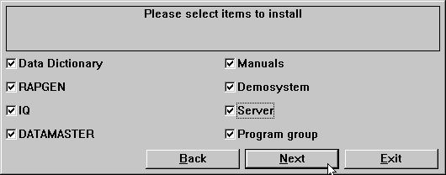

2. The installation selection

2.2.1. Installing a UNIX server using FTP
The installation now has buildin FTP access for easy transfer of the server program onto the Unix system.

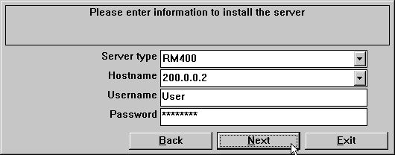

3. The FTP specification by server installation

2.3. Server programs
Previous versions of TRIO will run with the new server as well will the new release run with old servers. However we recommend the versions matches.
The new server of course includes support for the new interfaces and must be installed where these is to be used. Also the stability and speed of the new server program has been improved by use of blocking of network packages.
For OS/2 client systems multiple processes on TCPIP network could hang up the server. This problem is now solved.

2.4. Version number
The TRIO version number is found in the HELP-ABOUT menu or on any print of documentation from TRIO.

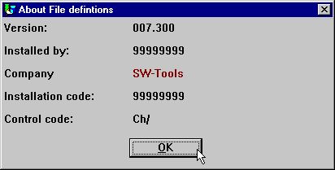

4. TRIO Version number
As shown the 32 bit version states 007.3xx as 300 is added to the minor version number.

2.5. Licensing
TRIO 32 bit requires own license codes.
User administration requires special license code.
Without maintenance you will need an upgrade version code to use TRIO 007.xxx if installation is before 01/08-1998.
A licensecode issued for TRIO version 007 may be used with version 006 also. You may have to update the product table contained in the textfile LICENSPR.SSV as all product codes must be known to the license program.

3. The Data Dictionary

Minor enhancements to the field format has been done as described below, and some new packtypes has been implemented due to support of new database systems.
Logical index definitions has been introduced to allow definition of pseudokeys for non-indexed files and the READ has been reworked for this.
The year 2000 triggers the additional secondary packing (calculation) on fields.

3.1. Number of fields increased to 999
The number of fields in one filedefinition has been increased from 499 to 999.

3.2. Floating decimals
By use of 9,5? you may now define a field which is output with 0 to 5 decimals as 123 or 123.45678 dependent on the actual field value.

3.3. Thousand editing
Request of thousand editing of 6 or 8 digit fields has been honoured as:
,6, or ,8, gives date fields (,4, is reserved for time)
,6,0 and ,8,0 and ,4,0 may be used for 999.999 / 99.999.999 / 9.999
.

3.4. Index key definitions, LOGICAL index
The meaning of index / directory numbers has been worked over.
Whenever you refer to an index for example by selecting this by start of a report of by reading a file using READ(xx.NN) you refer to the LINE NUMBER in the index definitions.
The LINE NUMBER in the definition now becomes a LOGICAL INDEX NUMBER which may or may not reflect the physical directory stored in the files.
As the index lines previously was sorted according to the directory number of the file all existing definitions have LINE=DIRECTORY so no backwards compatibility problems will occur.
This sorting has been removed for all other than DATAMASTER files enabling you to define the indexes in which order you want. The index order is used for example when searching in IQ.
The DIRECTORY number stated on a key definition line is for use by the database driver only for the physical search in the directory. It has nothing to do with the INDEX number NN stated in READ(xx.NN)
One DIRECTORY may occur multiple times as LOGICAL index lines defining different ways of building a searchkey. This is sometimes used in BASIC files as an example you could state different "XX" constants as logical index without having to duplicate the complete file definition.

3.4.1. Directory 00 recordnumber reading
Also you may now define an index connecting to directory 00 also, which means record number reading. This index may be selected by start of a report just like others and you may even define a KNIR field (Key Not In Record) becoming the recordnumber when this index is used.

3.4.1.1. ACCESS using SWODBC on non-indexed files
Microsoft ACCESS do have problems accessing any file without index defined. Defining index 00 as above overcomes this problem.

3.4.2. Suppressing IQ search on specific index (*xx)
One or more index may be omitted from the standard IQ search by stating the directory number as *XX. The index is skipped unless you specifically select this to be searched in the IQ program.

3.4.3. Suppressing index update for a specific index (-xx)
Stating -XX as directory number courses BASIC files not to update the file according to this index definition. May be used when defining multiple index for a file.

3.4.4. Creating a pseudoindex for a file (+xx)
- THIS FUNCTION IS FOR THE TIME BEING NOT FINALLY RELEASED -
.
Stating +XX as directory number, where XX is a non-present physical directory in the file, causes the extended SSV interface (see this) to construct the index as needed. Always set XX=Line number so the physical constructed index becomes equal to the logical index used.
The index may be used just as it was physically present. In case of use of a server the index is constructed here, not on the local PC.
Due to the complexibility of this function it will not be finally released in this version of TRIO as very extensive tests are needed. However you may find this testrelease useful.

3.4.5. Index example

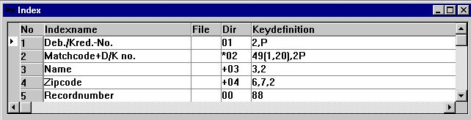

5. Example of pseudoindex and recordnumber definition

3.4.6. Key options, Descending index
A couple of keyfield options has been added:
I = Invert all bits in the keyfield (Descending index)
C = Global files only, Compress DMAM index
S = Global files only, Do not invert the sign bit of numeric field
.
An index definition as: 5I,2 will invert all bits in field 5 thus defining a descending index.

3.5. File connection definitions
As any READ(xx.NN) now lets NN reference the LOGICAL INDEX LINE number this is the case also when defining file connections inside the FDF.
For a connection in the column DIRECTORY you state the LOGICAL INDEX LINE which should be used to read a file.

3.5.1. Multiple connections to the same file using upper/lower case
READ(xx) searches for a connection to file xx stated in lowercase first, if not present the first connection found is used regardless of case. XX, Xx, xX may be used to state different connections. The sorting of file connections in the FDF has been changed so all connections to a file is shown together regardless of case.

3.5.2. Multiple connections to the same file using logical index
READ(xx.02) will use the connection given to LOGICAL index 2 of file XX. This may also be used to state more connections with different fields.

3.5.3. Forcing connections by READ
READ(aa.bb) will read the file bb using a connection from aa->bb.
READ(aa.bb.02) will read the file bb using a connection from aa->(bb logical index 2)

3.6. Packtypes for fields
The following field packtypes has been added:

 | Type | Name | Is stored as | Usage
 | 1053 | LDCHARR | Right justified field no extra byte as 1043 | C-Isam
 | 1121 | NAVI_STR | Textstring | Navision P5
 | 1122 | NAVI_DATE | Date structure | Navision P6
 | 1123 | NAVI_TIME | Time structure | Navision P3
 | 1124 | NAVI_BLOB | Binary large object | Navision
 | 1125 | NAVI_BOOL | Boolean | Navision P2
 | 1126 | NAVI_S16 | Short | Navision P7
 | 1127 | NAVI_S32 | Long | Navision P8
 | 1128 | NAVI_U8 | Char (byte) | Navision P1
 | 1129 | NAVI_ALFA | Textstring with 1.byte=Length | Navision P
 | 1130 | NAVI_BCD | Amount | Navision P9
 | 1131 | NAVI_O32 | Optioncode | Navision P4

3.6.1. Secondary packtypes
Due to year 2000 updates is has been necessary to introduce a secondary packtype which can be seen as a fixed calculation performed just after the field has been read and unpacked according to the Pxxxx packtype, or just before the field will be packed and written to the record. The secondary packtype is given as Vxx within the field format as: ,6,V1

 | Type | Name | Calculates | (Default) Parameter ZZ
 | V | YYMMDD | Shortdate YYMMDD -> YYYYMMDD | (50) Year 2000 when YY<=ZZ
 | V1 | DDMMYY | Shortdate DDMMYY -> YYYYMMDD | (50) Year 2000 when YY<=ZZ
 | V2 | DDDDDD | Daynumber DDDDDD -> YYYYMMDD | (0) Baseday V2.BASENUMBER
 | V3 | NXU2000 | Basic unpacked ZYmmdd, Z=?@ABC --> 00-09 | None
 | V4 | NXP2000 | Basic packed ZYmmdd, Z=space+,-. --> 0-4 | None
 | V8 | OCTAL | Convert from octal string by read, "1234" -> 668 | None
 | V16 | HEXA | Convert from hex string by read, "abcd" -> 43981 | None

3.6.1.1. Secondary packtype parameters
A parameter may be given together with the secondary packtypes as: ,6,V1.30 This may be used to overrule the default year wrapping by converting to/from short date formats.

3.6.1.2. Default secondary packing for BASIC dates
For short date fields (,6,) in BASIC files the secondary packtype will default to V for numeric fields, V3 for alphafields and V4 for packed fields. These rules are also applied to any keyfields containing short dates.

4. Year 2000

As TRIO is integrating to many different file systems all sort of year 2000 patching and tricking are seen.
Among others support for X-Basic COMET dates as alpha plain or packed in index keys has been added as described under packtypes.

4.1. Preferences
The preference setup for TRIO now includes a X-mark defining all dates being internally handled as YYYYMMDD independent of how these should be stored in the files.
This enables writing of calculations independent of the sometimes complex conversion rules made to solve the year 2000 problem in the file systems.

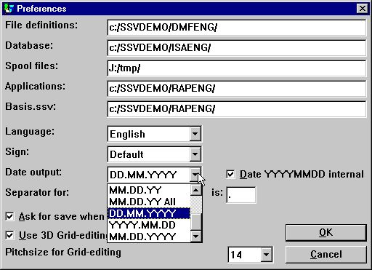

6. Preferences

4.1.1. Date output format
Possibility to output dates as DD.MM.YYYY and the American way round MM.DD.YYYY has been added:
0 = No conversion
1 = ,6, -> DD.MM.YY
2 = ,6, -> YY.MM.DD
3 = ,6, and ,8, -> DD.MM.YY, ,8,& -> DD.MM.YYYY
4 = ,6, and ,8, -> YY.MM.DD ,8,& -> YYYY.MM.DD
5 = ,6, -> MM.DD.YY
6 = ,6, and ,8, -> MM.DD.YY ,8,& -> MM.DD.YYYY
7 = ,6, -> DD.MM.YY, ,8, -> DD.MM.YYYY
8 = ,6, -> YY.MM.DD ,8, -> YYYY.MM.DD
9 = ,6, -> MM.DD.YY ,8, -> MM.DD.YYYY
.
Note the new options as DD.MM.YY-All with the possibility to override the ,8, YYYYMMDD output also.
A ,6, field will for nice output editing be threated as ,6,&' which means leading zeroes and zero suppression.

4.1.2. Internal date calculation format
- BE CAREFULL BEFORE YOU ACTIVATE THIS OPTION -
.
If your system stores dates in the short format YYMMDD you have had to take care of this if you calculates on date fields in all reports and IQ programs.
This may have been done with calculations on a ,6, field #47 like:
IF 19000000+#47>#DD LET #99=1
.
If you activate the YYYYMMDD calculation option all shortdates will be converted by reading(writing) the files to long format YYYYMMDD year 19xx/20xx.
You will have to change your calculations after activating this:
IF #47>#DD LET #99=1
.
It is of course preferable that the reading does the date conversions itself but great care should be used when activating on live systems.

4.2. Server and file update
You must observe that writing to files will require server version 007.001 if the index keys are to be constructed with shortdate conversion.

4.3. Date sorting
If you sort on a shortdate ,6, field the sortfile will be builded with ,8, dates. The same rule is applied on grouptotals in the report generator.
Year 2000 is also sorted correctly by use of ORDER BY on any ,6, shortdate field.

4.4. DOS dates
DOS and equivalent systems will return 100 for year 2000.
A date field of ,6, or ,8, with value between 1.000.000 and 1.999.999 will be assumed to be in year 2000.

4.5. Date function updates
All the date functions has been proved to work with year 2000.
The buildin calendar for the WORKD function has been extended until year 2010, please remember to update your individual table if you use workday calculations.

4.6. Year 2001 problem
Note that the FNY function will have a problem if you passes DDMMYY dates:
FNY(31.03.98) = 1998.03.31 ok
FNY(31.03.00) = 2000.03.31 ok
FNY(31.03.01) = 2031.03.01 YYMMDD is preferred instead of DDMMYY
.

4.7. Year 2005 problem
In BASIC packed keys the first packed character is handled as year 2000 when not a digit. 5 such characters are available: space,plus,comma,minus,point reaching from year 2000-2004 only.

4.8. Year 2010 problem
In BASIC unpacked keys the first character is handled as year 2000 when this is a question mark (?) enabling year 2000-2009.
TRIO will handle ?@ABCDEF... as year 200x,201x,202x,... also.

4.9. Year 2100 problem
When the year is added to a shortdate YYMMDD year 2000 is assumed when YY is less than 50.
When the system date passes year 2050 the same rules will be applied just for next century.

4.10. Date input validation
By input of date fields the following rules now applies in the stated order:
0. Input 0 -> 0
1. Input DD -> DD+MMYYYY from system date
2. Input DDMM -> DDMM+YYYY from system date
3. Input DDMMYY -> DDMMYY+TT from system date as above
4. Input DDMMYYYY -> DDMMYYYY, is accepted in ,6, fields also
5. Date validation according to preferences
6. If fails, Date validation as: DDMMYYYY, YYYYMMDD and MMDDYYYY
.

4.10.1. IQ selection date input
When you use the transaction selection input in IQ for date fields, your input and the date field will be passed the FNY function always to ensure the year is set.

4.10.2. CHAIN function masked date input
When you use CHAIN to start a report the dates you may pass by the function call will be threated as input just as by manual start of the report.

5. Database interface drivers

The number of database interfaces for TRIO is growing and extending the possibilities for the user to mix or convert from/to many platforms.

5.1. BASIC Interfaces
The following lists the available BASIC interfaces:

 | Type | TRIO Interface | Other software needed | Write | Bits
 | XBasic-Unix | XBasic
 |  | CTRAS (Library) |  | Write
 |  | CTRAS | CTRASX.DLL | Write | 16 only
 | XBasic-NT | X-Basic
 | Quattro | CTRAS | CTRASQ.DLL | Write | 16 only
 |  | Quattro (FTP) | SSQ |  | 32 recommended
 | X/Net | X/Net
 | Netbasic | Netbasic
 |  | CTRAS | CTRASQ.DLL (Netbasic) | Write | 16 only
 | Unibasic | Unibasic
 | Surfbasic | Unibasic
 | CX-Basic | Unibasic
 | OpenBasic | OpenBasic

5.2. NETBASIC using CTRAS functions
For NETBASIC a CTRAS-like DLL may been supplied from your Netbasic supplier which opens the possibility of both reading and writing to Netbasic files.
The DLL must be installed if you are having Netbasic version 4.29 or higher, with version 4.28 or lower you may use the SW-Tools buildin Netbasic interface.
When using the DLL you should follow the installation guide for CTRAS interfaces, as well as you should have a CTRAS license for TRIO.
Unlike the Quattro/XBasic CTRAS interface reading backwards in files are implemented for Netbasic.

5.3. Quattro interface using CTRAS
Note that the CTRAS library functions for Quattro are 16 bits only and will not be released as 32 bits in the near future.
Due to different problems with the interface no 16 Bits Windows server will be released with TRIO either. Instead the FTP Quattro interface as described below may be used with TRIO 32 Bits.

5.4. Quattro interface using 32 Bit FTP
An alternative to the rather slow CTRAS interface is now offered to the Quattro users which has a network connection and the SSQ FTP server available.
The interface uses FTP to pull over the complete files from the Quattro which are much faster than reading the single records whereafter a local read of the Quattro-format files are done. To allow long filenames we recommend the 32 bit version to be used as conflicts may occur if filenames are truncated to xxxxxxxx.xxx by the 16 bit version.
The files are transferred when opened by a report/IQ program or ODBC request and the frequency of update can be tuned for everytime, once a hour, once a day or like.

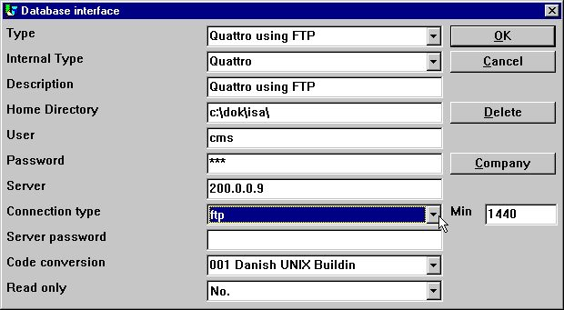

7. Setting up Quattro using FTP
When activating the connection type as FTP input to the field MIN is activated. Her you may state the number of minutes between the FTP transfer of a file or in another way how old you will accept your data to be before new update.
Above is given 1440 = 24 * 60 minutes. Thus the files is updated once a day by firsttime usage.
If you leave MIN blank or set it to 0 files are refreshed each hour.

5.4.1. Working offline with the Quattro files
If you set MIN to -1 files are never transferred, you will continue to run on files once received from the Quattro.
If a file cannot be transferred due to connection is not available an error message is given. If an earlier transferred file is available the program will use data from this without new transfer.
You may transfer files manually to the PC from a quattro system also using the FTP (see this) or tape transfer. The Quattro interface are working with exact binary copies of the Quattro files including the header block.

5.4.2. File definitions
No direct import of the Quattro file definitions are available, these must be loaded otherway.

5.4.3. XBasic and other interfaces using 32 Bit FTP
In practice you may use any of the buildin interfaces to transfer files using FTP and then running with local files. For example XBASIC on a RM system may be set up as:

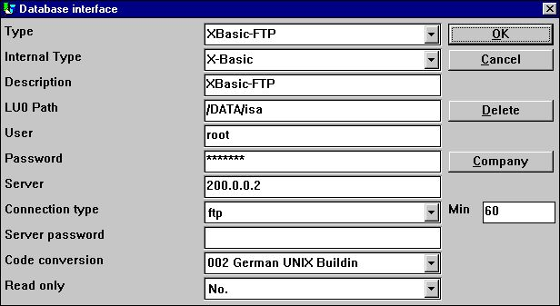

8. Setting up XBasic using FTP
However one path only is available which means the local path will become the same as the path on the server. The local path will be created if not present.
By the way you should note that the XBasic interface, also in CTRAS-Library write mode, may be used on an UNIX system even if XBasic itself is not installed.

5.5. GLOBAL 3000 Speedbase and Global 2000 ISAM/DMAM
TRIO now supports these systems. A separate installation manual is available on request.

5.6. NAVISION Financials
The 32 bit version of TRIO and the ODBC driver now interfaces the Navision Financials package by use of the C-Front module which must be present on the system. Both read and write are implemented, C/FRONT version 1.2 or higher is supported.

5.6.1. Install Navision Financials and C/FRONT
Install Navision Financials and C/FRONT for example in directory e:\fin and make sure that the PATH environment variable includes the directory e:\fin. If you change the PATH variable restart the Windows system.

5.6.2. Install and configure the Navision Financials interface
Follow the description for installing a ODBC driver interface in TRIO. The interface for Navision is named 'Navision Financials'. By the function 'Database-interface' you may select the installed 'Navision Financials' where the following setup will correspond to the described sample installation.

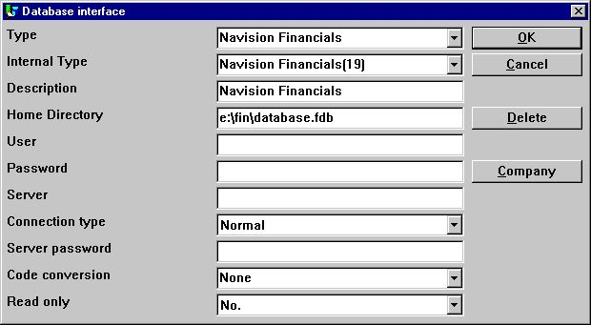

9. Sample setup of Navision Financials interface
If you use C/FRONT with TCP/NETB for server connection the field Server may be used to enter 'server,type' where server is the server name and type is tcp or netb.

5.6.3. Import of table definitions
From the menu 'File' - 'Import ODBC definitions...' you may select interface 'Navision Financials' in order to import all or some of the table definitions.

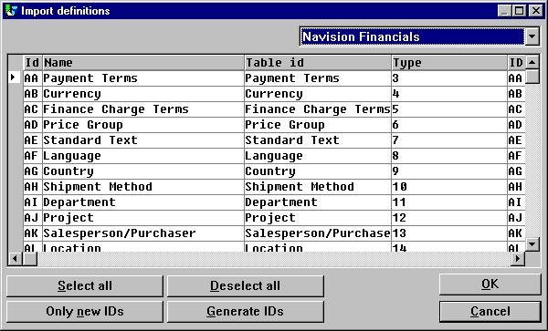

10. Import of all or some of the Navision table definitions

5.7. CONCORDE C5/XAL
Concorde C5/XAL interface is available as 16 or 32 bits as readonly for TRIO and the ODBC driver.

5.7.1. Exporting the Concorde file definitions
If Concorde is installed for example in directory e:\concorde you should first export all file definitions into a .DBD file.
The export may be done by login as 'supervisor' and select the menu 'Generel' - 'Amendments' - 'Development menu'. From here you may select 'Export' - 'DBD' - 'All + Enum'. The exported file is then saved in the same directory as the Concorde installation, e.g. e:\concorde.

5.7.2. Install and configure interface to Concorde
Follow the description for installing a ODBC driver interface in TRIO. The interface for Concorde is named 'Concorde C4' or 'Concorde C5/XAL'.
By the function 'Database-interface' you may select the installed 'Concorde' where the following setup will correspond to the described sample installation.

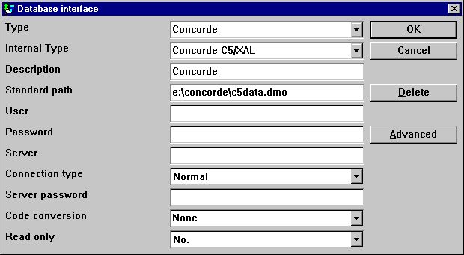

11. Sample setup of Concorde interface

5.7.3. Import of table definitions
From the menu 'File' - 'Import ODBC definitions...' you may select interface 'Concorde' in order to import all of the table definitions.
A user name is required in order to import definitions. The user name is 'BASIC'.
When the user name has been entered the import will be of all tables, e.g. no selection can be made. If required you may delete one or more of the imported definitions afterwards.

5.8. Btrieve version 5.10 and 6.15
Btrieve files can be accessed directly without use of ODBC. This will give a much better performance when working with TRIO.

5.8.1. Install and configure interface to Btrieve
Follow the description for installing a ODBC driver interface in TRIO. The interface for Btrieve is named 'Btrieve'.
By the function 'Database-interface' you may select the installed 'Btrieve' where the following setup will correspond to access of Btrieve files located in the directory 'e:\btrieve'.

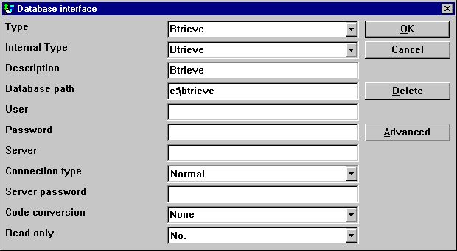

12. Sample setup of Btrieve interface

5.8.1.1. Advanced options
The Btrieve interface allows you to control how files are to be opened and how the file name should be generated.

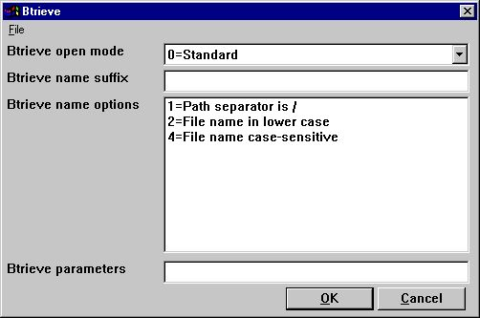

13. Advanced settings on Btrieve interface

5.8.1.1.1. Open mode
The open mode may be one of the following:
- Standard
- Exclusive
- Single Engine File Sharing (Version 6.15 only)
- Multi Engine File Sharing (Version 6.15 only)
.
By standard TRIO will open a Btrieve file in read-only mode unless it is a file which is to be updated on a report or in a DATAMASTER program.
When the open mode is Exclusive, no other program can gain access to the file.
The Single and Multi Engine File Sharing modes are for Btrieve version 6.15 only. Please refer to the Btrieve documentation for a detailed description of the openmodes.

5.8.1.1.2. Name suffix
The name suffix of a Btrieve file was always set to .DAT in TRIO version <= 006.008. However, Btrieve files may be without any suffix or a different one than .DAT. Therefore, it is a field you may fill yourself when installing the interface for use in TRIO.

5.8.1.1.3. Name options
These options controls how the file name of a Btrieve file is generated by TRIO. The naming options for a Btrieve may override the normal generation of the actual file location. As an example, assuming that the interface has been setup with database path
c:/btrieve/database
and a file is defined with name
customer
and the suffix is set as
dat
the actual location of the file is
c:/btrieve/database/customer.dat
Because Btrieve does NOT allow the use of / in the path the default behaviour is to replace all occurrences of / with \ giving a location as
c:\btrieve\database\customer.dat
Should this however change in newer Btrieve versions or only be dependent on the operating system used, it can be changed here.

5.8.1.1.4. Parameters
When Btrieve 5.10 is activated it is required to pass some initial parameters to the Btrieve system. The parameters are by default:
/m:48 /b:16 /f:20 /l:20 /p:4096
.
Please refer to the Btrieve 5.10 manual for a detailed description of the possible parameters and the meaning hereof. The parameter string has no effect when using Btrieve 6.15 or newer.

5.9. ODBC drivers interface - Application type
An application type option can be used to control how TRIO should integrate to an ODBC driver as there may be differences in the SQL language / options dependent on the driver supplier.
Note that more types may be set at the same time by adding the values.

5.9.1. Type 1 - Support of Informix Database table locks
The normal use of an ODBC data source for Informix will lock any used table when connected to it. This will for example course a problem if a user is working with IQ or RAPGEN to query or print information from the Informix database at the same time when a user wants to work with the table from another application.
It is described in the Informix database documentation that you have to execute a SQL statement 'set isolation to dirty read' to avoid the problem.

5.9.2. Type 4 - Always perform ORDER BY
Because not all ODBC drivers support the standard given by Microsoft, you may experience SQL errors when trying to print reports with access to a table using the ODBC driver. The error will state a missing ORDER BY ... for the table.
A report that selects the fields from a customer table, where customer is the primary key will generate
SELECT customer,name,address FROM customer_table
If type 4 is set it will generate
SELECT customer,name,address FROM customer_table ORDER BY customer
.

5.9.3. Type 4096 - Alpha fields may NOT be NULL
Because some ODBC drivers / SQL Databases does NOT support alpha numeric fields with no content, e.g. "" it is necessary to inform TRIO that all alpha fields must contain some value.
This type will automatically use the field pack type 1048 on all fields, which will set the content of an empty alpha field to one space.

5.9.4. Type 8192 - ODBC Drivers with support of one connection per table only
Because some ODBC drivers / SQL Databases requires a unique connection for each table, where as TRIO tries to optimise table access by doing the connection to the database only once it can be necessary to set this type.
If this type is set, TRIO will create a connection to the database for each table used. Please note, if the ODBC data source requires the user to enter a user name / password to connect to the database, it will be required to do so for each table used. To prevent this, the user name and password must be setup one for the database interface in TRIO.

5.10. ISAM database interface - Application type
The application type may be used for ISAM also for company control:

5.10.1. Type 2 - Support of SAMSON system
The SYSTEM named SAMSON, is a financial system for DOS/Windows and UNIX, using C-ISAM as Database. In this system, all files are created with a company number as the first key part always. TRIO supports the use of company numbers on interfaces and sub systems, but normally only in connection with the file name.

5.11. SSV database interface
The SSV interface for Semicolon Separated Textfiles has from TRIO (007.001) been completely reworked and optimised for speed improvement and compatibility on keystructure. Compressed files has been implemented for diskspace saving also.
You do normally not have to set up any options for the SSV interface but the following ADVANCED options will be available:

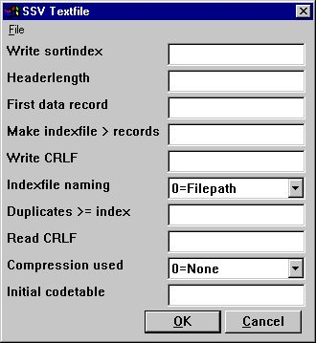

14. The ADVANCED options with the SSV driver
Note that when you move the mouse cursor over the field leading text you will get floating online help displayed.

5.11.1. Write sortindex
Determines sorting by write of the file.
0 = No sorting, recordnumbers (lines) are kept
>0 = Sort the file according to this index definition
.

5.11.2. Headerlength
Used by the SSV interface only, sets the first valid data byte of the file.

5.11.3. First data record
First data record used in the file, records below this number are ignored.
First real data position is calculated as: Headerlength + First data record * Recordlength
In case of SSV files containing lines of text the first data record indicates the first line to be used. The default when blank is 1 causing a headerline to be reserved. Set to 0 if you want the first line to be included. The field may be given as:
512 Decimal
0x200 Hexadecimal
*8,B16P1006
.
where the last line marked with an leading * states that a field with the format 8, should be read from the file exact byte position 16 and unpacked using packtype 1006 used as value here.

5.11.4. Make indexfile > records
Huge SSV files may require time sorting each time the file is opened and an index is used.
This parameter defines that for files larger than X records an external indexfile should be kept and used whenever possible. The default is to keep indexfiles for files larger than 10000 records.
Such files may be placed on the TMP directory or together with the file itself depending on the naming parameter.

5.11.5. Write CRLF
A SSV file will normally be written using the same CRLF characters as original read from the file. On a new file LF = 0x0A is used. You may specify a fixed crlf for write hexadecimal here as:
0x0a = LF only
0x0d = CR only
0x0a0d = LF+CR
0x0d0a = CR+LF
.

5.11.6. Indexfile naming
If an indexfile is build for large SSV file, the filepath is determined based on this parameter:
0 = filepath/filename.Xnn
1 = TMP/filename.Xnn
.

5.11.7. Duplicates >= index
Duplicates will normally not be allowed in an index.
If you define a matchcode index you will normally have to separate equal keys yourself which may be done by adding recordnumber as NP to the key definition.
However you have the possibility also to define that all index above the here given number will allow duplicate keys. When a SSV file is read all index will always allow duplicates anyway as the build of the file may be done in many ways.

5.11.8. Read CRLF
When reading a SSV file the CRLF sequence will normally be automatically detected and used also by potential write. However you may fix the crlf as for the write crlf, see above.

5.11.9. Compression used
By use of 1 the file may be compressed using the LZ standard in Windows with the COMPRESS / EXPAND programs saving space.
When you set 1 a compressed file will be autodetected and read just as any other file, however you will have to manually compress the files as writing will always be done uncompressed.
0 = No compression favours the fasted read speed for the file.
1 = May be compressed
.

5.11.10. Initial codetable
The normal codetable specified for the driver is used by converting individual alphanumeric fields from the file.
By giving a codetable number here you can convert the complete file directly after read or directly before write meaning that the field separator characters and linefeeds may be converted also.

5.12. Extended SSV interface
Extended SSV parameters for each file are now available whereby not only textfiles but many plain files fits into this interface.
Even complex filestructures as fixed recordlength X-Basic indexed files may be defined naturally just for direct access only skipping the index part. However setting up such driver requires you have excessive knowledge of the file system details.
The ADVANCED options may be set by the driver installation or for each file also as an PARAMETER button is added to the main file information screen:

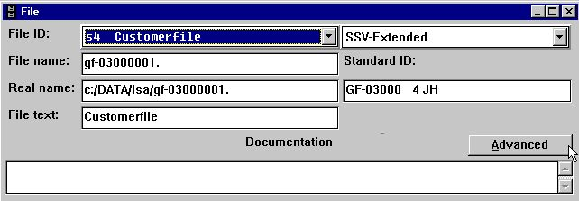

15. The PARAMETER button for single files.

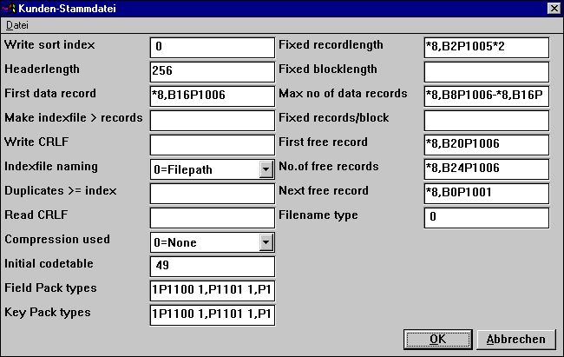

16. The ADVANCED PARAMETER for the extended SSV driver defining a X/Net file

5.12.1. Fixed recordlength
Filling this field changes a SSV file from variable to fixed recordlength, enabling the extended SSV interface to access many different filetypes. The field may be:
*8,B2P1005*2
.
stating that a field with the format 8, should be read from the file exact byte position 2 and unpacked using packtype 1005 and multiplied by 2.

5.12.2. Fixed blocklength
Together with a fixed recordlength a blocklength may be given fitting a certain number of records into one block and possible leaving a gap between the blocks. The blocklength may be given directly or as an number of records/block. The field may be:
*8,B2P1005*2
.
stating that a field with the format 8, should be read from the file exact byte position 2 and unpacked using packtype 1005 and multiplied by 2.

5.12.2.1. Max no. of data records
A SSV file may be restricted to use a maximum number of records within a larger database or diskarea. The field may be:
*8,B8P1006-*8,B16P1006
.
stating that two fields with the format 8, should be read from the file exact byte position 8 and 16 and unpacked using packtype 1006 and subtracted from eachother.

5.12.3. Fixed records/block
Together with a fixed recordlength a blocklength may be given fitting a certain number of records into one block and possible leaving a gap between the blocks. The blocklength may be given directly or as an number of records/block.

5.12.4. First free record
A first free data record may be given to the SSV interface in order to skip over reading all free data records by following the free record chain. The field may be:
*8,B20P1006
.
stating that a field with the format 8, should be read from the file exact byte position 20 and unpacked using packtype 1006.

5.12.5. No.of free records
A number of free data records may be given to the SSV interface in order to skip over reading all free data records by following the free record chain. The field may be:
*8,B24P1006
.
stating that a field with the format 8, should be read from the file exact byte position 24 and unpacked using packtype 1006 and used as value here.

5.12.6. Next free record
A free data record chain may be defined where each free data record points to the next in order to skip over reading all free data records by following the free record chain. The field may be:
*8,B0P1001
.
stating that a field with the format 8, should be read from the actual record byte position 0 and unpacked using packtype 1001 used as pointer to the next free record.

5.12.7. Filename type
Reserved for future use, leave this field as 0.
Determines which driver interface should generate the filename and possible other parameters for use by the SSV.

5.12.8. Field Pack types
May be used by fixedlength files only, a normal SSV file always uses SSV packing.
The packtypes may be given directly on the fields as e.g. P1013, or the default may be given here for each fieldtype separated by blank.
1P1100 1,P1101 1,P1102 1,P1103 1,P1104 1,P1105 1,P1106 1,P1107
.
gives the normal BASIC packing of Alpha, 1 word, 2word, ... , Call 60 etc.
The first 6 being for fieldtypes 0-5 followed by P0-9

5.12.9. Key Pack types
As fields packtypes but used when a field is used in a key, se above.
A normal SSV file always uses LDCHAR/CALL60 when a field is places in a key.

6. Printing

6.1. Screen printer enhancements
The screen setup in TRIO may now be given multiple time by setting the check mark for screen printer on an empty printer line in the setup dialog.

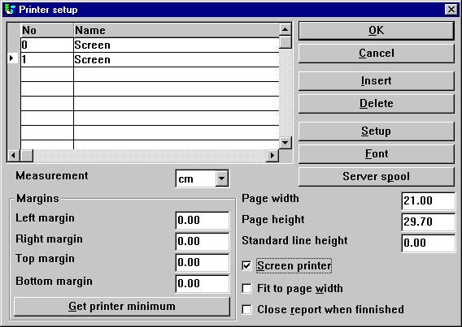

17. Additional screen printer insertion
Different screenprinters may be setup with different pagesize and as you will see below may be used for Multi Output Format to textfiles, HTML and RTF also.

6.1.1. Saving the screen print to a file
In the file menu for the screen printer display a possibility has been added to save a print to a file and to recall this later.

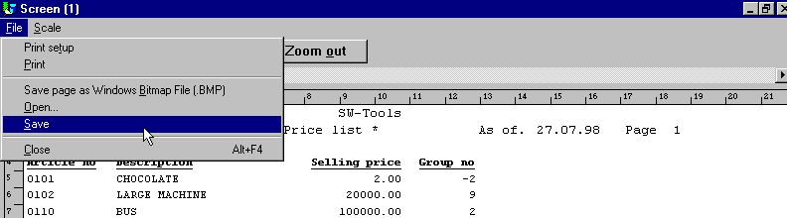

18. Saving a screen print to a file
However you should note that special print as charts and OLE linked objects will not be included into to saved print.

6.1.1.1. SCRPRT function for IQ print recall
The SCRPRT("filename") function in IQ may also be used to recall the print.

6.2. Multi Output Format printers
In general TRIO now provides a number of new printers which may be setup initially as a screen printer. The button 'Setup' can now be used to set the type of printer output for the defined screen printer.

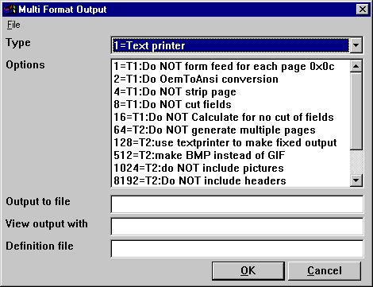

19. Setup of screen printer to Multi Output Output printer
The options possible for a Multi Output Format printer will be described separately for each printer type. One or several options may be selected for a printer. You should note that hardcopy of a screen is not possible on this type of printer as the hardcopy will always go to the Windows default printer.

6.2.1. Printer type
The printer type may be one of the following:
1 - Text
2 - HTML
3 - RTF
4 - TXT
5 - SSV
.
The printer output definition is stored in myprt999.ini which must be present on the installation. The following is installed with TRIO:
Type 2 - myprt002.ini
Type 3 - myprt003.ini
Type 4 - myprt004.ini
Type 5 - myprt005.ini
.
You may change these definition files by copying the one matching the type of printer you are using for example to
myhtml.ini
.
make amendments to it and setup the printer to use this definition file instead.

6.3. Text printer, Printertype 1
Because the Window Generic text printer has its limitations and does not produce a very good and useably content, TRIO now has its own text printer. The output will be into one file, where each page is separated by a form feed (the hexadecimal character 0x0c). The printer will automatically calculate the width of any field used in the layout in order to produce an output with no overlapping fields.

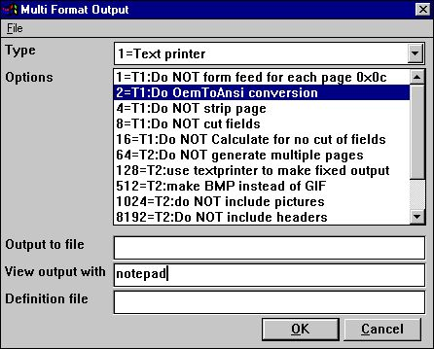

20. Sample setup of TEXT printer viewed in notepad

6.3.1. Options
The options beginning with
T1 : xxxx
is used by this printer. None of the T2 options are valid!

The printer will as standard add a form feed after each page printed. If you require to print all pages with no form feed select option 1.

TRIO will as standard convert all characters to OEM format, e.g. the format known to MS-DOS. Hereby, it is possible to use the file in MS-DOS, where all language specific characters are properly translated. The file may for example be viewed with MS-DOS EDIT. If the file is to be used in Windows the option 2 must be selected in order to get language characters correctly translated because Windows uses ANSI character set. If option 2 is set you may for example view the file in notepad, wordpad, word or others.

Internally the text printer generates a page with x columns and y lines. This page is then filled until overflow of lines is encountered. At this point, the page will normally be stripped, e.g. trailing blanks on lines and trailing blank lines are removed, which gives a small and compact file. If you want the page output with the real length of each line including all lines select option 4.

TRIO always cuts the fields width according to the field box size defined. E.g. if a text field of 30 characters is defined with a field box width only allowing approx. 20 characters only 20 characters will be printed. If required to output the entire field content disregarding the field box size select option 8. Please note the description of option 16.

As described for option 8 all use of standard windows printer drivers in TRIO will cut fields according to a box width. However, this text printer will as standard try and calculate the box width of all used fields to avoid any missing characters from fields printed. In other words, the printer tries to expand the box width of any field used. To avoid it, select option 16.

6.4. HTML printer, Printertype 2
The HTML (Hyper Text Markup Language) printer can be used to produce output directly to internet/intranet systems. This means, an output from this printer can directly be viewed in your internet/intranet browser, e.g. Netscape, Explorer or others.
The output may also be send as attachment to an e-mail, whereas the receiver of the mail may then view the report directly in a browser.
Because HTML does NOT support any pixel positions the printer can be used in two ways.

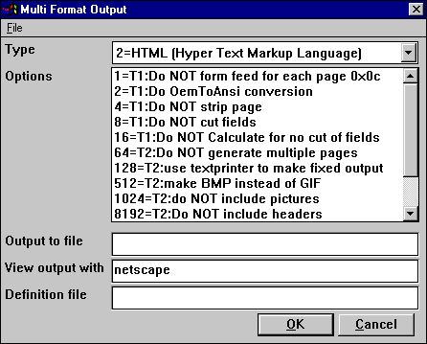

21. Sample setup of TEXT printer viewed in Netscape

6.4.1. HTML output of standard reports
TRIO will have no problems with standard reports. The report will be converted to a HTML table, where each field corresponds to a column in the table.
Any total level or group total defined will be inserted in the same table.
All used pictures, OLE objects and charts will automatically be converted to the standard picture format GIF (Graphical Interchange Format) known to HTML.

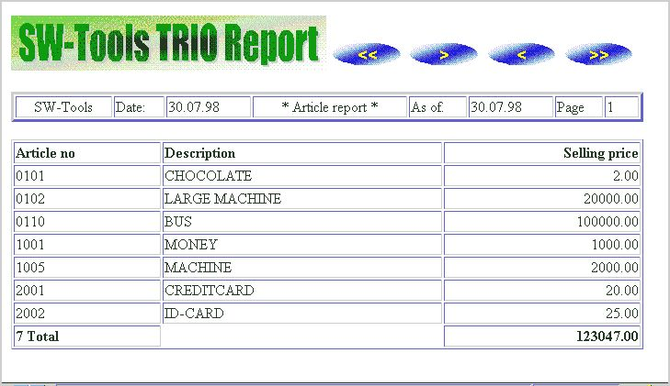

22. Sample HTML output of standard report in Netscape

6.4.2. HTML output of non-standard reports
Please refer to the description of option 128 and 2.

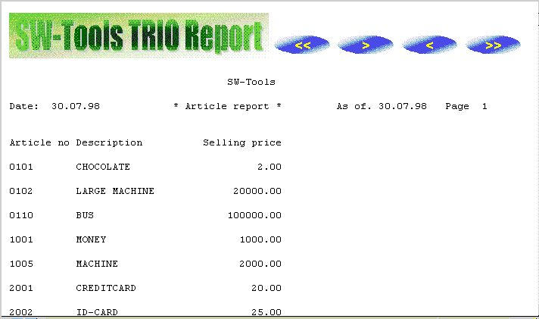

23. Sample HTML output of non-standard report in Netscape

6.4.3. Background, logo and browse buttons
When you print a report on the defined HTML printer, the definition file myprt002.ini contains a number of references for a standard logo and browse button pictures. These picture files are found in the TRIO installation directory in GIF format:
htm-bkgn.gif - Background
htm-logo.gif - Logo
htm-frst.gif - Browse to first page button
htm-next.gif - Browse to next page button
htm-prev.gif - Browse to previous page button
htm-last.gif - Browse to last page button

6.5. RTF printer, Printertype 3
The RTF (Rich Text Format) printer produces output in the same way as the HTML printer. The output from here can as an example be used to include directly in a Microsoft Word document.
The only difference between the RTF and HTML printer lies in the definition file used, so please refer to the description of the HTML printer.

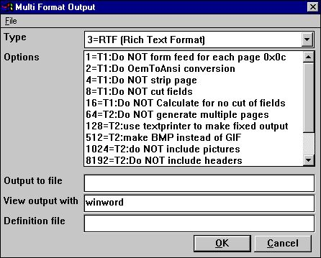

24. Sample setup of RTF printer viewed in Microsoft Word

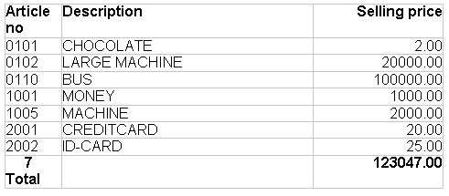

25. Sample RTF output in Microsoft Word

6.6. TXT printer, Printertype 4
The TXT printer equals the type 1 text printer, but will standard generate multiple text files, e.g. one file per page printed. This means, no form feed character is inserted in the files.

6.7. SSV printer, Printertype 5
The SSV (Semi-colon separated file) printer produces output of a standard report only (please refer to HTML output of standard reports).
Each definition part of the report is written to the SSV file where each item used in the layout corresponds to a field, and each field is separated by a semi-colon.
For example, if you have defined a report with printout of the article number, description and selling price, using the standard RAPGEN heading, the output will be:
Company name;Date;98.06.07;......
Article number;Description;Selling price
0101;aaa;123.45
0102;bbb;4.567.89
2 Group 01;4.691.34
...
The printer will not replace any occurrence of semi-colons in text fields.

6.8. Options for printer type 2 - 5
The options beginning with
T2 : xxxx
is used by this printer. The T1 options are only valid if type is 4 or the option 128 is selected.

The printer will generate a separate file for each page, e.g. the filename will be
xxxxx999.yyy
.
where 999 is the page number. If you want the output in one file only select option 64 and the filename will be generated as
xxxxxxxx.yyy
.
Please NOTE, if using TRIO 16-bit version the filename is limited to a maximum of 8 characters xxx plus 3 characters yyy, e.g. only 5 can be used because 3 characters is used for page number.

If you have reports defined, which cannot directly be converted into a table you might experience a wrong output from the printer. However, you may select the option 128.
When the option is selected the report output will be correct, because it is a simple text output using a fixed font.
For this fixed output no pictures, OLE objects or charts will be included.

When printing in HTML format the standard picture file format is called GIF (Graphical Interchange Format) whereas when printing in RTF format the standard is BMP (BitMaP - Standard Windows picture file format). Normally you have no need of selection this option. It will automatically generate GIF files when using the HTML printer and BMP files when using the RTF printer.
If you want to use the BMP for the HTML printer instead select option 512.

These options speak for themselves. For example, if you want to output in SSV format, but only the totals defined on a report select options 1024, 8192, 16384 and 65536. Given the sample in section 'SSV printer, Printertype 5' the only line will be:
2 Group 01;4.691.34

6.8.1. Output to file
This filename may contain path and file name for output. If working with TRIO 16-bit version the name may not exceed 8 characters plus 3 characters as extension. The syntax of the file name must be
[<drive>:][<path>]<filename>.<extension>
.
The default drive and path is the same directory as TRIO is installed in.
The default filename is always swxxx.yyy where xxx and yyy is set according to the options on the printer:
00 = htm
04 = rtf
32 = ssv
64 = txt
.
which means that with no options set the default file name is
swhtm.htm
.
If printing to multiple files there must be enough free characters in the file name to add the file number 999, e.g. page 5 is named
swhtm005.htm
.
A sample of a file name could be:
c:\webfiles\swrap.htm
.

6.8.2. View output with
The field is used to view the output.
Assuming the output is in HTML format and you have the Netscape browser installed in directory c:\programs, you could view it by calling
c:\programs\netscape.exe <filename>
.
We cannot tell you exactly which application to use for viewing the output, but only show some samples
HTML: Netscape or iexplore.exe
RTF: wordpad.exe or winword.exe
TXT: wordpad.exe or notepad.exe
.
Please NOTE: It may be necessary to enter the program name with complete path!

6.8.3. Definition file
The default definition file for the printer type 2 is:
myprthtm.ini for HTML output (Option 00)
myprtrtf.ini for RTF output (Option 04)
myprtssv.ini for SSV output (Option 32)
myprttxt.ini for TEXT output (Option 64)
.
You may define your own definition file by copying the default. If you do, enter the name of the new definition file here.

6.9. Printing Labels
The subfunction PRINT() can be used to produce print of labels in a very simple way. The function syntax is:
PRINT(LAB=direction, columns, rows, width, height, copies)
.
The direction control how to generate the labels on the label sheet. The valid values are:
0 - No labels
1 - From left to right
2 - From top to bottom
.
The multiply of number of columns and rows is the actual number of labels on one sheet.
The width and height of any label on the sheet can be given in centimetres or inches by using the following syntax:
7cm equals 7 centimetres
2in equals 2 inches
.
Finally when printing labels you may want to print multiple copies of the same label, which can be controlled by the copies parameter.
A sample use of the PRINT(LAB=...) function could be:
PRINT(LAB=1,3,7,7cm,7cm,2)
.
which will produce labels printed from left to right on a label sheet with 21 labels, 3 on each row, 7 rows, where each label has the width/height of 7 centimetres. Each label is printed in 2 copies.

6.9.1. How to use in RAPGEN
To produce the simple print of labels a report must be defined as a letter. The main file of the report should as an example be the customer file if you want to print customer labels.
On the layout of the letter you only require to define one label in the top left part of the layout.
When the label is defined you must remember to change the Page control, which is normally set to :1,1-99 for a letter, to 1-x where x is the number of lines used to define the label.
Finally you have to add the following calculations to the report:
FIRST
PRINT(LAB=1,3,7,7cm,7cm,2)
.
Please remember to have the PRINT(LAB=...) in the FIRST section. Otherwise, it will reset the label control for each record read from the main file.

6.10. RAPGEN start parameter
RAPGEN may be selected from the Windows icon with the following parameter:
RAPWIN -m Always open dialog screen when report starts

7. Calculations

The calculations in IQ and RAPGEN has been extended with DIALOG function which also works as an extensive help function wizard:

7.1. Wizard function helper
You should select a calculation line containing any function call and then from the EDIT menu activate the wizard of simply press CTRL.Q on the line.

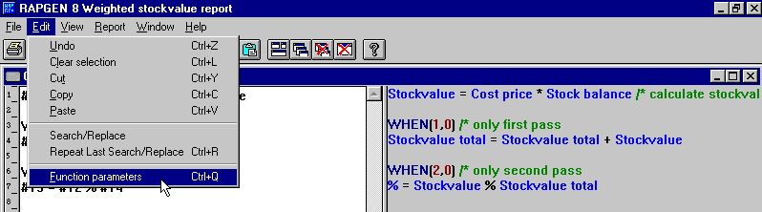

26. Activating the function wizard
The wizard now finds the nearest function name on the present line and makes an input dialog based on the help manuals.

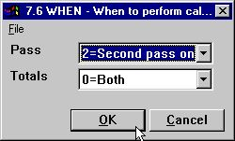

27. The function wizard for WHEN
Which means you will get the parameters shown in clear text and these can be selected from the allowed values.
If you move the mouse cursor over the fieldnames you will get the function manual documentation shown as floating help.
In case of a new calculation line to be entered you may just enter the function name, say READ followed by CTRL.Q

28. The function wizard for READ
The wizard also integrates to the Data Dictionary whereby it is able to let you select files and their indexes from a listbox.
If you check the EXAMPLE field the example from the manual will be included in your program, you may afterwards have to change the fieldnumbers to get a working result.
For some functions the wizard may offer you additional help by adding a button for options, BROWSE when selecting a filename or as below COLOR when selecting a color:

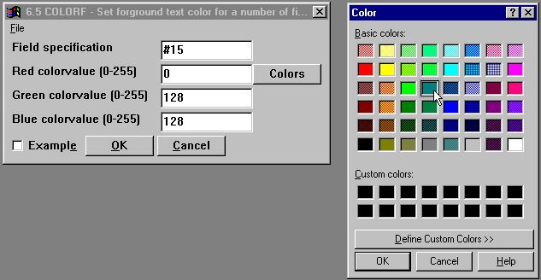

29. The function wizard for COLOR
You should always see the wizard as a helping tool when defining a program but at the same time observe that some functions may have so specialised use that the wizard cannot show all the possibilities. For example with READ the use of Upper/Lowercase fileID's and forced connections will not be supported by the wizard.

7.2. External DLL functions
Functions may now be integrated into TRIO by the special manual file definitions 00-99 where each field will have a reference for an external DLL, a function name, prototype and hold the function documentation also.
In this way the file description acts both as a user manual, wizard definition and programming interface. The use of these functions are just like any other function in TRIO which in fact makes an automatic INSTALL (see this) when such a function is used. The Data Dictionary will for functions hold a prototype also.
It is not intended that the user himself shall define such functions but they will be seen in extensions such as the Chart and OLE interface and opens for a wide range of programming possibilities.

7.3. DIALOG function for additional input
The DIALOG function enables the user to pop up dialogboxes with a selected set of fields at any point of a report execution or in an IQ program for example by click on a field.

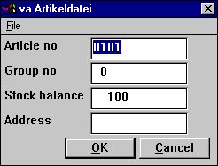

30. DIALOG("#1,7-8,le#3") in an article query
DIALOG("#1,7-8,le#3") defines a dialog with the given fields. The fields documentation is used if present as floating online help when the mouse cursor is moved over the leading text.
A number of options may be stated together with the fields such as C for Combobox, L for Listbox with valid values, W for field width and so on. These are described in the subfunction reference part of this manual. In fact are many of the new dialogs in TRIO made with the same function.

7.4. PARAMS function for additional report start parameters
PARAMS("#1,7C,6O,le#3") is a variant of the dialog function where the input is done by start of the report not during report execution.
Use of PARAMS in a report will add a button <Extra parameters> to the startup screen which then activates the dialog.

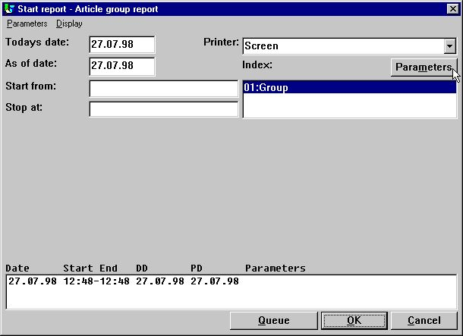

31. PARAMS("#1,7C,6O,le#3") on an article report
You may also use the DIALOG function on a report but note the difference that PARAMS takes input by report start, DIALOG when the report is actually running which means it should be placed as FIRST or under some IF control.

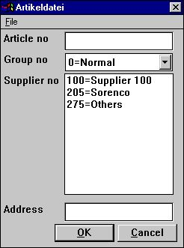

32. The input screen for PARAMS("#1,7C,6O,le#3")

8. Subfunctions

The calculations has been extended with the following functions.

8.1. DIALOG - Function for additional input
Number DIALOG(Fields par1)
Parameters: Par1: Fields to show in the dialog
Description: The DIALOG function enables the user to pop up dialogboxes with a selected set of fields at any point of a report execution or in an IQ program for example by click on a field.
DIALOG("#1,7-8,le#3") defines a dialog with the given fields. The fields documentation is used as floating online help when the mouse cursor is moved over the leading text.
Together with a field you may state one of the following additional options:
Lxxxx Line (dialog units)
Pxxxx Position (dialog units)
Hxxxx Height (dialog units)
Wxxxx Width (dialog units)
N No leading text
N1 Add fieldnumber to leading text
N2 Display leadingtext above field instead of left of field
C COMBOBOX, Field check definitions shown as values
O LISTBOX, Field check definitions shown as values
:xx Skip to next column fieldline xx
+xx Skip xx fieldlines down
Returnvalue: OK=0, CANCEL=1
See also: PARAMS
Example:
DIALOG("#1-3,11") /* Make a dialog with the given fields

8.2. PARAMS - Function for additional report start parameters (RAP)
PARAMS(Fields par1)
Parameters: Par1: Fields to show in start parameter dialog
Description: PARAMS("#1,7-8,le#3") is a variant of the dialog function where the input is done by start of the report not during report execution.
Use of PARAMS in a report will add a button <Extra parameters> to the startup screen which then activates the dialog.
Returnvalue: None.
See also: DIALOG
Example:
PARAMS("#1-3,11") /* Make a dialog with the given fields

8.3. FTP - File Transfer Processor
number FTP(Number par1, Text par2)

Par2: FTP command
Description: The FTP function has been build in to enable advanced users to transfer files for example in a report based on a SSV file containing filenames. For a complete set of commands you should consult a FTP manual. Note that freefields may be used for the command and that the 32 bit version supports long filenames.
The example shows the transfer of a file from a Quattro system with the special command QUATTRO for transfer with headerblock and XQUAT to remove the additional FTP informations from the so transferred file.
Returnvalue: For OPEN: FTP Handle, all other: FTP error code, 0=OK
Example:
#10=FTP(0,"open 200.0.0.9") /* Connect to Server
#11=FTP(#10,"user cms mypas") /* Log in as user cms password mypas
#11=FTP(#10,"binary") /* Switch on binary transfer
#11=FTP(#10,"quattro") /* Switch on Quattro backup mode
#11=FTP(#10,"get /X.BASIC/0/AFIL c:/mydir/myfil") /* Get the file
if #11<>0 FTP(#10,"error") /* Display error message
#11=FTP(#10,"xquat c:/mydir/myfil") /* Convert from Quattro
#11=FTP(#10,"quit") /* Thats it

8.4. GETINFO - Get additional program information (IQ/DM)
number GETINFO(number par1, text par2)

par2 : Field reference
Description: This function allows you to get some special information from an IQ/DM program. The type 0 and 1 will return the unique id of the window, which may be used by other functions to manipulate the window. A sample of this is present in the OLE manual.
When the type is 2 to 5 the function requires a field reference in par2. For example, to get the start column for article field number 7 par2 should equal "va#7". The coordinates of a field is here given in the actual size of the field defined in IQ/DM.
If you require the actual coordinates of a field according to the scale factor currently used, e.g. zoom in/out, use the type 6 to 9 instead.

Type 2-9 returns a field coordinate. The value can be held in a 9,T2 field format.
Example:
GETINFO(0) /* Get the IQ program window id
GETINFO(2,"va#7"); /* Get the start x coordinate of va field 7

8.5. LINE - Retrieve or set the current line number (IQ/DM)
number LINE(number par1)
Parameters: par1 : Type of information to get
Description: The function will retrieve or set the IQ/DM line number. The line number is the counter for lines defined in a program defined as va#1-6l or le#1-6/va#1-6.
If par1 equals 0 the function returns the line number of the currently active line.
if par1 equals -1 the function returns the number of lines defined for the programs. If the programs was defined as va#1-6l,t5 the return value would be 5
if par1 is greater than 0 the function sets the active line to par1.
Returnvalue: A line number/count or zero if the functions sets the line number.
Example:
#20=LINE() /* Get current active line number

8.6. OBJECTGETSTRING- Get index of an objects selected item (IQ/DM)
text OBJECTGETSTRING(field par1)
Parameters: par1 : Field on the form, e.g. va#7
Description: The function retrieves the normal value of the combobox/listbox field. It returns the value equal to the par3 used when calling OBJECTADDSTRING.
The use of this function will normally be by click on the combo/listbox field.
Returnvalue: The normal (index) value of the current selected item.
See also: OBJECTADDSTRING
Example:
#20=OBJECTGETSTRING("va#6") /* Get current selected supplier number

8.7. PRINT(LAB= - Label function (RAP)
PRINT(LAB=Text par1, Text par2, Text par3, Text par4, Text par5, Text par6)

par6 : Copies
Description: The width and height of any label on the sheet can be given in centimetres or inches by using the following syntax:
7cm equals 7 centimetres
2in equals 2 inches
The below sample produces labels printed from left to right on a label sheet with 21 labels, 3 on each row, 7 rows, where each label has the width/height of 7 centimetres. Each label is printed in 2 copies.
Returnvalue: None.
See also: PRINT
Example:
FIRST
PRINT(LAB=1,3,7,7cm,7cm,2) /* Define label print
NORMAL

8.8. SCRPRT - Recall screen print (IQ)
SCRPRT(Filename par1)
Parameters: Par1: Filename to show using the screen printer
Description: SCRPRT("filename") calls up the screen printer with the saved print from filename. This may for example be used in IQ by click on a field.
Returnvalue: None.
See also: PRINT
Example:
SCRPRT("c:/w/ab.cde") /* Show this file using the screen printer

8.9. SHOW- Enable/Disable/Show/Hide a field (IQ/DM)
number SHOW(field par1, number par2)

3 = Hide field
Description: This function allows you to enable/disable a field or show/hide a field.
Returnvalue: None.
Example:
SHOW("va#7",1) /* Disable field va#7

8.10. USERINFO - Get information about user
text USERINFO(number par1)

17=User defined
Description: This function gets the requested user information.
The number in Par1 refers to the fieldnumber in the system file US where you may define field 11 to 17 individually for each installation, just be careful if later upgrading the version of TRIO.
Returnvalue: String containing the user information.
Example:
#11=USERINFO(6) /* Get the user first remark

Figure list
1. The CDMENU selection 9
2. The installation selection 11
3. The FTP specification by server installation 12
4. TRIO Version number 14
5. Example of pseudoindex and recordnumber definition 26
6. Preferences 37
7. Setting up Quattro using FTP 55
8. Setting up XBasic using FTP 58
9. Sample setup of Navision Financials interface 62
10. Import of all or some of the Navision table definitions 63
11. Sample setup of Concorde interface 66
12. Sample setup of Btrieve interface 69
13. Advanced settings on Btrieve interface 70
14. The ADVANCED options with the SSV driver 82
15. The PARAMETER button for single files. 93
16. The ADVANCED PARAMETER for the extended SSV driver defining a X/Net file 94
17. Additional screen printer insertion 106
18. Saving a screen print to a file 107
19. Setup of screen printer to Multi Output Output printer 109
20. Sample setup of TEXT printer viewed in notepad 111
21. Sample setup of TEXT printer viewed in Netscape 113
22. Sample HTML output of standard report in Netscape 114
23. Sample HTML output of non-standard report in Netscape 115
24. Sample setup of RTF printer viewed in Microsoft Word 117
25. Sample RTF output in Microsoft Word 117
26. Activating the function wizard 128
27. The function wizard for WHEN 128
28. The function wizard for READ 128
29. The function wizard for COLOR 129
30. DIALOG("#1,7-8,le#3") in an article query 131
31. PARAMS("#1,7C,6O,le#3") on an article report 132
32. The input screen for PARAMS("#1,7C,6O,le#3") 133

Index

A
ANSI 112
B
Basic 33;52
BCD 32
BMP 120
C
CANCEL 135
CHAIN 50
Combobox 131
Concorde 64;65;66;67;145
CRLF 87;90
Ctras 4
CTRAS 4;52;53;54;55;58
D
DATAMASTER 20;71
DLL 52;53;130
Duplicates 89
F
FDF 28;29
FTP 3;12;52;54;55;56;58;137;145
G
GIF 114;116;120
Global 27;59
GLOBAL 59
H
Height 135
HELP 14
Hexadecimal 85
HTML 106;110;113;114;115;116;117;119;120;122;123;145
I
INDEX 20;28
Informix 76
INSTALL 130
Installation 9
Interface 52
IQ 5;6;7;20;23;39;49;55;76;108;127;131;135;138;139;140;142;143
ISAM 59;80;81
L
LET 39
Listbox 131
N
Navision 32;60;61;62;63;145
Netbasic 52;53
Netscape 113;114;115;122;145
NT 4;52
O
Object 6
OBJECTADDSTRING 140
ODBC 55;60;62;63;64;66;67;68;69;75;76;77;78;79
OEM 112
OLE 3;6;107;114;120;130;138
OPEN 137
P
Preferences 37;145
PRINT 124;125;141;142
Printertype 111;113;117;118;119;120
Q
Quattro 4;52;53;54;55;56;57;137;145
R
RAPGEN 76;119;125;126;127
Recordlength 85
RTF 106;110;117;120;122;123;145
S
Server 13;40;62;137
Sort 83
SQL 75;76;77;78;79
SSV 15;25;82;84;85;86;87;88;89;90;93;94;95;97;99;100;102;103;104;110;119;120;123;137;145
SWODBC 22
T
TRIO 1;3;4;5;6;7;9;10;11;13;14;15;25;36;37;46;51;52;53;54;59;60;62;64;66;68;69;71;72;73;75;78;79;81;82;106;109;110;111;112;114;116;120;121;130;131;144;145
U
UNIX 12;58;81
W
Wizard 128
X
X-Basic 4;36;52;93

