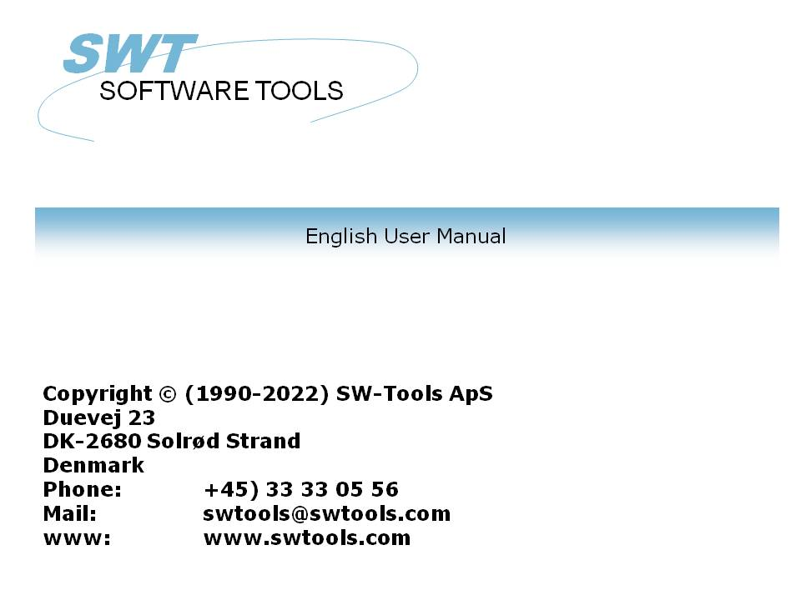

IQ User Manual

22/11/01 / 2022-09-01 008.384

Contents
Contents 2
1. Preface 5
1.1. Starting IQ 6
1.1.1. Licence information 7
1.2. About the user interface 8
1.3. Hardcopy function 10
2. Defining a query 11
2.1. Selecting table and fields 12
2.2. Query on list form 17
2.3. Query with relationship between tables 18
2.4. Query on main and transaction table 21
2.5. History on selected table fields 22
2.6. Syntax of the query definition 23
2.7. Special options in definition 24
2.8. Preferences for new queries 26
2.8.1. Add field numbers in front of names 27
2.8.2. Omit field names 28
2.8.3. Background colour 29
3. Query search functions 30
3.1. Data retrieval 31
3.1.1. Next data record 32
3.1.2. Previous data record 33
3.1.3. Specific record 34
3.1.4. First data record 35
3.1.5. Last data record 36
3.2. Superindex search 37
3.2.1. Interrupting SUPERINDEX 38
3.2.2. Superindex fields 39
3.3. Selections. 40
3.3.1. Selection on numeric values 42
3.3.2. Selection on text 43
3.3.3. Selection on field from secondary tables 44
3.3.4. Multiple selections and OR selections 45
3.3.5. Selection on calculated values 46
3.3.6. Using subfunctions in selections 47
3.3.7. Selections as calculations 48
3.3.8. Removing the selection 49
3.3.9. Saving the selection 50
3.4. The index menu 51
3.4.1. Display current key 52
3.4.2. Case sensitive search 53
3.4.3. Index locked 54
3.4.4. List must match input key 55
3.4.5. Index names and definitions 56
4. Transaction queries 57
4.1. Next page 58
4.2. Previous page 59
4.3. First page 60
4.4. Last page 61
4.5. Reverse display order 62
4.6. Superindex on transaction lines 63
4.7. Selection on transaction lines 64
4.7.1. Standard selection fields on transactions 65
4.7.1.1. Amount field 66
4.7.1.2. Date field 67
4.7.1.3. Code field 68
4.7.1.4. Refno. field 69
4.8. Sum of transactions 70
4.8.1. Brought forward amount 71
4.9. Multiple screen lines / transaction 72
5. Saving, Deleting and documenting queries 73
5.1. Saving a query 74
5.1.1. Program number 76
5.1.2. Program name 77
5.1.3. Save desktop of all programs 78
5.2. Deleting a query 79
5.2.1. Amending a program without file access 80
5.3. Printing program documentation 81
5.4. Help and check on fields 83
5.4.1. Field documentation 84
5.4.2. Valid values 85
6. Program parameters 86
6.1. Created with the fields 87
6.2. Number of free fields 88
6.3. Global free field from number 89
6.4. Number of transaction lines on form 90
6.5. Background colour 91
7. Amending form 92
7.1. Inserting fields 93
7.1.1. Insert with field heading 94
7.1.1.1. Part of fields and tablefields 95
7.2. Inserting font specific text 96
7.3. Drawing rectangles, circles, lines and pictures 98
7.4. Deleting elements 99
7.5. Box sizing and field flags 100
7.6. Changing colour, font and justification 101
7.6.1. Pen 102
7.6.2. Colour 103
7.6.3. Text 104
7.6.4. Font 105
7.6.5. Justification 106
7.6.6. Bring to front / back 107
7.7. Object type and attributes 108
7.8. Moving, deleting and changing group of elements 109
7.8.1. Moving the group 110
7.8.2. Deleting the group 111
7.8.3. Changing the group 112
7.8.4. Blocks of lines 113
8. Calculations 114
8.1. Edit calculations 115
8.2. View of translated calculations 117
8.3. Picture fields 118
8.4. Functions 119
8.5. Entry points for calculations 120
8.5.1. After read of main table 121
8.5.2. By click on a field 122
8.5.3. By start of program 125
8.5.4. By end of program 126
8.5.5. After read of transaction table 127
8.5.6. Before DISPLAY of a field 128
8.5.7. OWN routines 129
8.5.8. Before TRANSMIT to other programs 130
8.5.9. By select of a FUNCTION 131
8.5.9.1. DOFUNCTION messages 132
8.5.10. By read of mainfile 133
8.6. Transaction queries and free fields 134
8.6.1. Sum of transactions 135
8.7. DEBUG in the calculations 136
9. Interaction between queries 137
9.1. Talk to other programs 138
9.2. Listen to other programs 139
9.3. Example of multiple queries 140
9.4. Interprogram communication 141
9.4.1. Program number 142
9.4.2. Fields from other programs 143
9.4.3. GOSUB common subroutines 144
9.4.4. GLOBAL variables A1,A2,... 145
9.5. DIALOG function for additional input 146
9.6. OLE 2.0 support 147
10. Start parameters and standard programs 148
10.1. IQ Start parameters 149
10.2. Standard programs 150
Figure list 151
Index 153

1. Preface

SW-Tools IQ is an intelligent query tool. After a very short introduction users are able to produce queries, simply selecting the required information's.
IQ is based on a Data Dictionary where all information of tables, fields, indices and relationships to other tables are predefined. The product offers a user interface where queries can search after text, calculate fields and automatically refresh the information in other opened query window's.
The system has access to many databases/filesystems and integration to ODBC that allows one query to access multiple databases of different types.

1.1. Starting IQ
When IQ is started for the very first time no programs has been defined. The system therefore starts with a view of fields from the first defined table in the Data Dictionary:

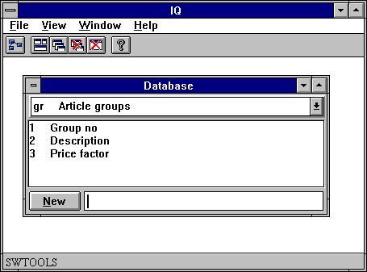

1. IQ

1.1.1. Licence information
IQ is copyrighted SW-Tools and your licence information is shown briefly whenever the program is started.

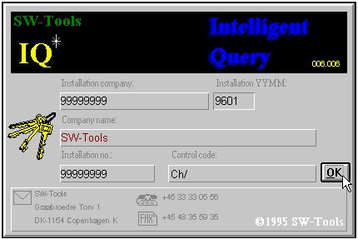

2. Licence screen
You are of course only allowed to use IQ according to your licence agreement.

1.2. About the user interface
To access the functions in IQ you may use the menus or the related buttons on the toolbar.

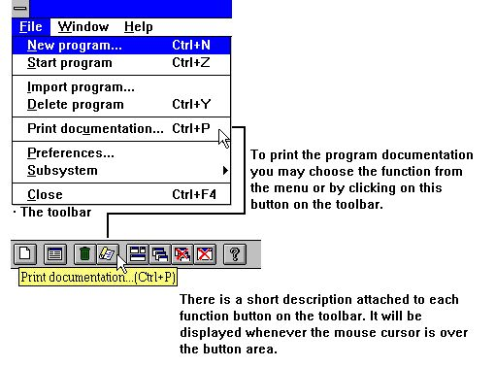

3. Accessing the functions using menus or the toolbar
Because the toolbar does not have room for all the functions in IQ, it will vary from function area to function area, as for the pulldown menus. For example you will view this toolbar when a query is active:

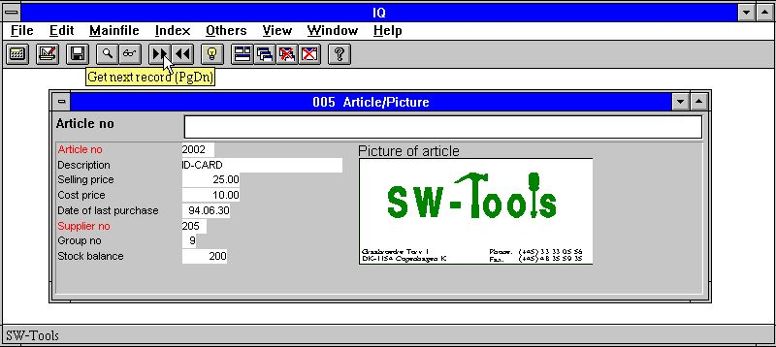

4. The toolbar during a query
Even though the menus and toolbar buttons changes between functions, IQ have some general functions attached on the toolbar. It is functions to arrange windows, closing the active window and access to the on-line manual. Because these functions are attached to the toolbar they will of course also be accessible from the pulldown menus:

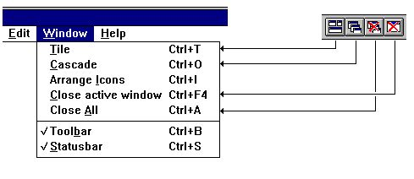

5. Generel menus and buttons

1.3. Hardcopy function
Due to problems with the text hardcopy font on different printers IQ will deliver a bitmap hardcopy of the screen instead if possible.
The menu has functions for a hardcopy of the active window only or of the full screen.

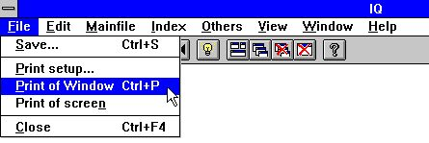

6. Hardcopy

2. Defining a query

2.1. Selecting table and fields
A query must be related to a table. Therefore the first selection necessary is the table id. It can be done by entering the id or selecting it from the following list:

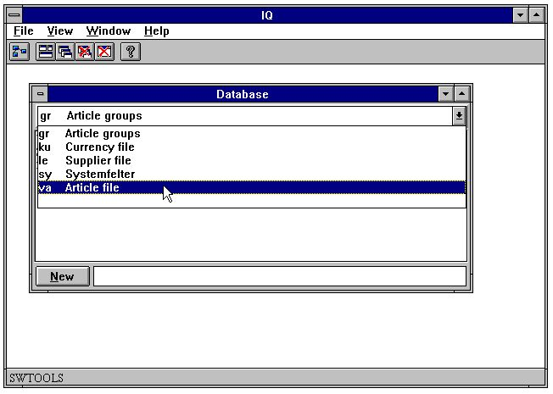

7. Selecting table id
When the table id is selected the fields will be displayed:

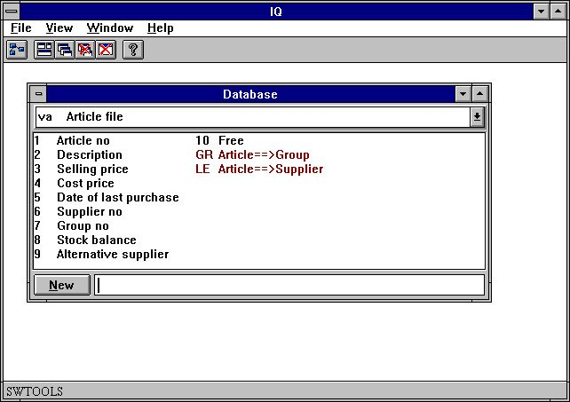

8. Table fields
Select fields required in the query by clicking on the fields in the listbox. For example, to define a query on the article table with information about
- Article number
- Description
- Selling price
- Cost price
- Date of last purchase
- Supplier no
- Stock balance
click on each field as shown here:

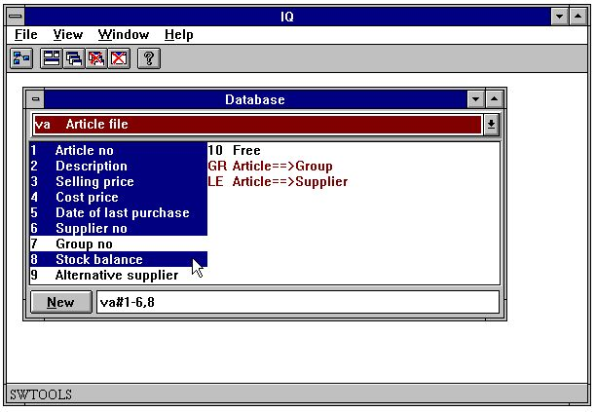

9. Example of an article query
Instead of using the mouse it is possible to enter the field sequence as:
va#1-6,8
When entering the fields instead of using the mouse, please remember the
#
after the table id, and then the field sequence.
The database window will automatically update the view of selected fields for the current table, in this case the article table.
When finished selecting the query information the query will be generated when choosing the following function:

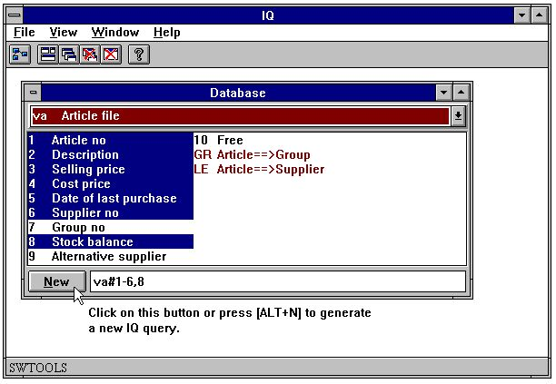

10. Generating the query
The query is automatically generated with a standard form. All fields are inserted with the field names as leading text and a data entry box where the actual value will be displayed.
IQ generates maximum 20 fields in a column. If many fields are selected it will generate a number of columns.
All fields are placed with correct justification, depending on the field format and type, e.g. numeric fields are right justified and text fields left justified.
The new article query uses one table only and the form looks like this:

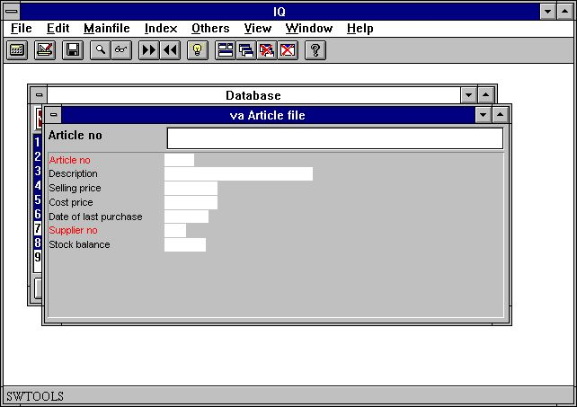

11. Query on one table
Fields marked in red is index fields for search, see later.

2.2. Query on list form
Normally an IQ query generates a form with the fields selected setup in columns. This provides a form with information on one record at a time. However, it is possible to define forms where multiple records can be displayed, as a list of records.
The definition for a list form query is the exact same as already described, with one exception. The last character entered in the syntax must be the letter
l
This letter stands for 'list form' and may be entered in upper or lower case. If defining the query as
va#1-6,8l
the following query form will be generated:

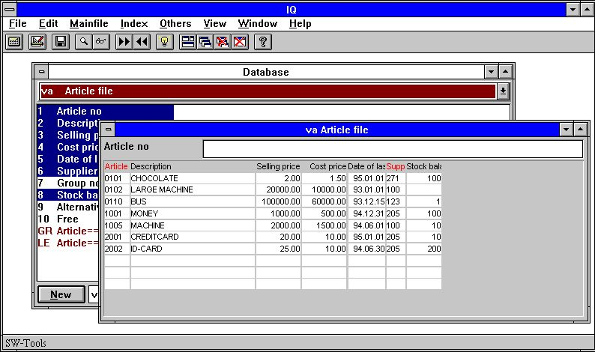

12. Query on list form
The form is generated with the selected field names as headings and then multiple field entry's beneath the headings, used to display the record contents.
The appearance order of the records depends of which search index are used, see later.

2.3. Query with relationship between tables
In many databases the defined tables are related in some way. An article table does not contain all information on the supplier, but it contains the supplier number which is the direct access to the supplier table. In other words, the article table is related to the supplier table, and therefore the supplier information may be retrieved for each article.
Because the relations may be defined in the SW-Tools Data Dictionary it is possible to define the query simply by selecting fields from both tables. The first step is to select the article fields as in the previously defined query and then add the requested supplier fields to the selection.
Apart from the fields defined, the database window also displays the defined relationships to other tables, and are always displayed in red. By click on the relation to the supplier table 'le':

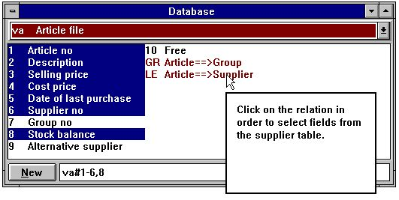

13. Relationship to other tables
the supplier fields can be added by clicking on the required fields:

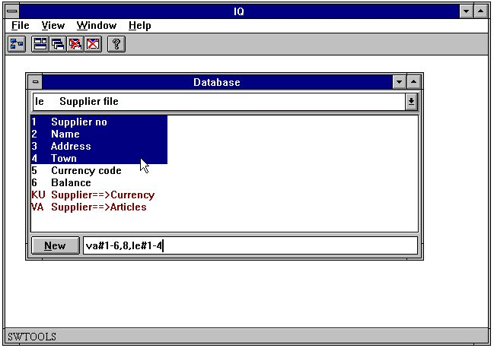

14. Selecting fields from a related table
The query form is generated with fields from both tables:

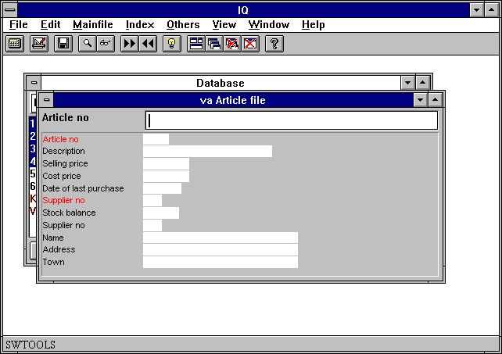

15. Query with relationship between tables

2.4. Query on main and transaction table
Queries on one table or more tables, where the relationship between the tables are 1 to 1, may be defined using the mouse. However, if a query is to be defined where the main table is related to a transaction table, e.g. each record in the main table has one or more transaction records, the definition has to be entered.
An example could be to query the supplier information and then all articles for each supplier. The first step is to select the fields to query from the supplier table:
le#1-6
Next it is required to define the transaction fields. To define that the fields are related to the transaction table the first part of the definition has to be separated by
/ (Division character)
giving the complete definition as:
le#1-6/va#1-6,8
The query on main and transaction table information will be generated in two steps. First the main table fields are inserted as normal in columns, then the fields from the transaction table are insert in a number of columns and rows. The example will generate the following query form:

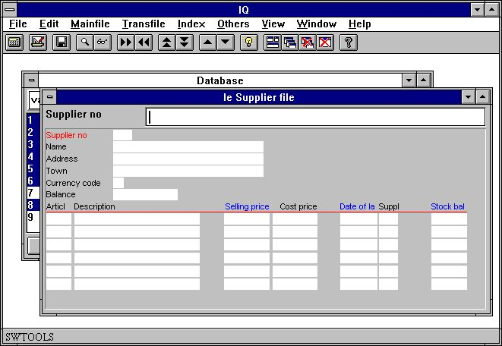

16. Query on main and transaction table
Fields marked in blue on the transaction line are selection fields, see later.

2.5. History on selected table fields
When queries has been defined IQ always remember the fields selected from each table. This means, if a query has been defined as
va#1-6,8
IQ remembers
#1-6,8
for the table 'va'. Later it is then possible to recall the selected fields just by entering
va
followed by the [ENTER] key. IQ then recalls the latest used definition which you then may amend:
va#1-6,8

2.6. Syntax of the query definition
As described queries can be entered as a definition. The following gives a number of examples on how the definition may be:

 | Definition | Description
 | va#1-6,8 | Query on article table field 1 to 6 and 8
 | va#1-6,8l | Query on article table field 1 to 6 and 8 on list form
 | va#1-6,8,le#1-4 | Query on articles including the supplier information
 | le#1-6/va#1-6,8 | Query on suppliers. Articles attached to the supplier
 |  | are also listed
 | le#1-6/va#1-6,gr#2 | Query on suppliers. Articles attached to the supplier
 |  | are also listed including the article group information

2.7. Special options in definition
A query definition may contain some special options to control how the form is generated. The options controls when to change to a new column how many lines to generate on the form, if field numbers has to be displayed together with the field names etc.
The special options are:

 | Option | Description
 | f | Add field numbers in front of names
 | o | Omit field names
 | t99 | Set maximum number of transaction lines to 99. The value 99 may
 |  | be set to any value between 1 and 99
 | h99 | Set maximum number of main table lines to 99. The value 99 may
 |  | be set to any value between 1 and 99
 | m999 | Set maximum column width. The value 99 represents characters and may
 |  | be set to any value between 1 and 999. The real width of the fields are
 |  | calculated using the font average character width.
 | :1 | End the current column and start a new one
 |  | For list or transactions :1 defines a query with multiple lines.
 | c=0 | Set check flag
 |  | 0 = No check, just display field
 |  | 1 = Combobox
 |  | 2 = Display field check as text
 |  | 3 = Display field value + checktext
 | n=10 | Limit fieldnames to max 10 characters

To define a query on articles with field numbers in front of the field names, define the query as
va#1-6,8,f
The form will be generated as:

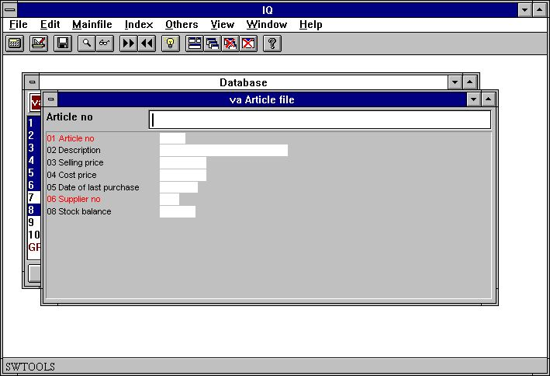

17. Query form with field numbers
Field numbers may be useful if you want to make selections. Please refer to 'Selections'.

2.8. Preferences for new queries
IQ provides you with a preferences dialog where some general parameters can be controlled for query programs.
The dialog contains the following:

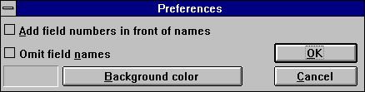

18. Preferences

2.8.1. Add field numbers in front of names
If you checkmark this option IQ will add field numbers in front of the field names when generating the program form. Please refer to 'Special options in definition'.

2.8.2. Omit field names
If you checkmark this option IQ will omit field names when generating the program form. Please refer to chapter 'Special options in definition'.

2.8.3. Background colour
You may select a background colour that will be the standard colour for all defined programs. The function activates the Windows standard colour selection dialog.
Previously defines programs will also use this colour as long as the program specific background colour hasn't been changed. Please refer to chapter 'Program parameters'.

3. Query search functions

3.1. Data retrieval
When a query has been defined it supports a number of functions to retrieve information from the tables used. The functions allows retrieval of one record at a time, going forward or backwards in the index defined for the main table. For example, the article table is defined with article number as index, and therefore it is possible to retrieve the first, next, previous and last article information. It is also possible to get an exact article directly by entering the article number.
If no record is found IQ will display an error message and afterwards clear the entry fields in the query.

3.1.1. Next data record
To retrieve the next record in the query use the following function:

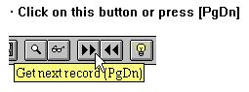

19. Next data record

3.1.2. Previous data record
To retrieve the previous record in the query use the following function:

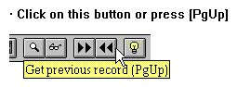

20. Previous data record
Note that not all database systems have got functions for retrieving previous record.

3.1.3. Specific record
When you enter a key IQ will find and display the record if possible.
IQ will automatically search all index defined for the table matching the enter input. For example, if the key value is entered as 205, which is not an article number but a supplier number, IQ searches the secondary index of the article table first. The article table has a secondary index defined, where the supplier number (3 digits) is the first entry in the definition, and therefore IQ will find the first article where the supplier number is 205.
IQ determines which index to use by matching the input key against the index definition. Each index is given a search priority calculated based on the entered value. If you enters 3 digits index with first field of length 3 is searched first, a numeric index is tried before an alphanumeric.
If you enters a match code containing letters a numeric index will not be tried. If not found IQ also try to search the entered value in uppercase (if you have not checked the 'case sensitive' option in the index menu).

3.1.4. First data record
You use this function to get the first record in the file. You may also just enter a space as search key followed by [ENTER].

3.1.5. Last data record
You use this function to get the last record in the file. Note that not all database systems have got functions for retrieving the last record.

3.2. Superindex search
Apart from the retrieval functions that uses the indices, IQ also has a super index function, searching freely in all records to find a text.
You may activate the search by entering the text to find and press [Shift+PgDn] or by click on the superindex icon.

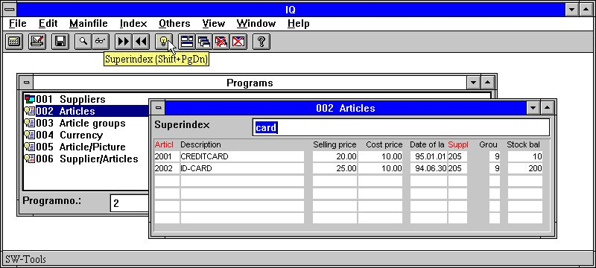

21. Superindex search
Superindex searches the complete file for any occurrence of the entered search key in any alphanumeric fields displayed on the screen with no regards to case and independent of where the text is placed in the fields.
Superindex does not search in numeric fields - for this you should use the selections described later.
For very large files this may of course take a moment but the search is extremely optimised and is carried out on the server only without transmitting all data to the client.

3.2.1. Interrupting SUPERINDEX
During the search for records the ESCAPE cursor is shown

22. The ESCAPE cursor
and you may interrupt the search by pressing escape (maybe a couple of times).

3.2.2. Superindex fields
By default IQ searches all main table alphanumeric fields displayed to find the requested text. You can use the following function to define which fields to search in:

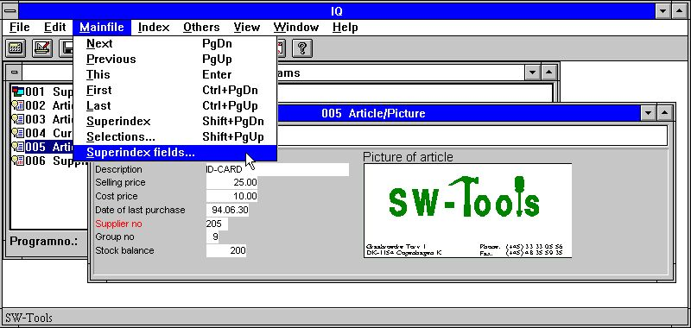

23. Function for superindex fields
You do not have to display the field on the screen in order to use superindex search on this.
The superindex fields may be entered in the following dialog:

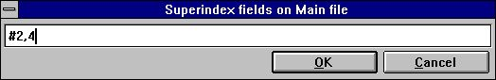

24. Editing superindex fields
Next time, when activating the superindex search function, IQ will only search in the field 2 (Supplier name) and 4 (Town).

3.3. Selections.
When retrieving data in the query program you may want to exclude some records depending on one or more field values. This can be done by entering a selection criteria.
If you for example have defined a query on articles, as:
va#1-6,le#2,f,l
where the option 'f' adds field numbers to the generated heading on the form. The normal list of articles contains the following:

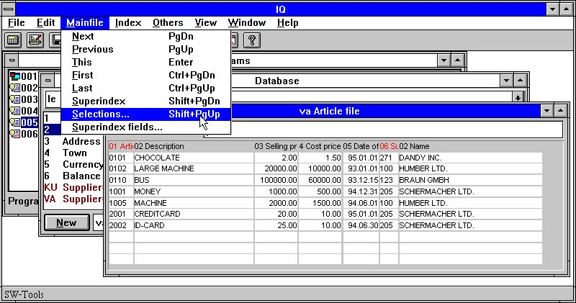

25. Normal article list query
If you only want to view the articles where the selling price is greater than 100 select the 'Selections...' function from the 'Mainfile' menu. In the selection dialog you may enter the selection as:

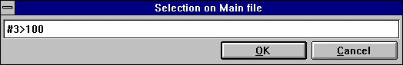

26. Selection on selling price greater than 100
The selection has been defined when you select [OK]. You may now enter a blank followed by the [ENTER] key to perform the query with the defined selection. The result is as follows:

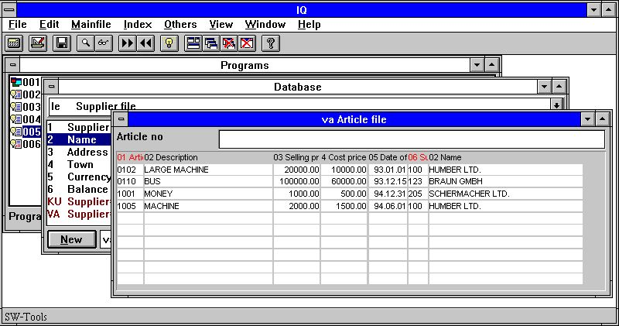

27. Result of query with selection
In general all selections are entered as one calculation line, where you may use operators and fields references. The field references may be entered as
va#3
to access the article table field 3 (Selling price). If the field is a main table field you need only to enter
#3
Because field references are used to access the field values it is recommended that the field number is present on the form, because the selection dialog doesn't display a field overview.

3.3.1. Selection on numeric values
Selection on numeric values is simply entered as:
#3 > 100
or if the value has decimals
#4 > 1.5
where the numeric constant has to be entered with a dot as decimal point. If entered as comma the selection is incorrect.

3.3.2. Selection on text
Selection on text is simply entered as:
#2 = "BUS"
to retrieve the articles where the description is BUS.
You may also enter selections on part of text fields by entering
#2(1,1) = "M"
to retrieve articles where the description start with the letter M.

3.3.3. Selection on field from secondary tables
If the query consists of more tables, for example the query definition
va#1-6,le#2,f,l
where the supplier name is listed for each article you may also select on the fields from the supplier table by entering:
le#2(1,1) = "S"

3.3.4. Multiple selections and OR selections
If the selection needed consists of more than one criteria you may use the logical operators
AND
OR
to construct the selection line. For example, to select the articles where the selling and cost price is greater than or equal to 1000:
#3 >= 1000 and #4 >= 1000

3.3.5. Selection on calculated values
If the query contains calculated free fields, for example the stock value calculated in free field 20 as
#20 = #4 * #8 /* stock value = cost price * stock balance
you may select the articles where the stock value is greater than zero by entering:
#20 > 0
It is however also possible to define the same selection without using the free field, because IQ supports calculations in the selection. To define the selection on Stockvalue you may enter
#4 * #8 > 0
thus first calculating the stock value as #4 * #8 and then selecting the calculated value greater than zero.

3.3.6. Using subfunctions in selections
Subfunctions can also be used in the selection line. For example, the selection on the article description
#2 = "BUS"
will only find articles where the description equals "BUS" in capital letters. If the article table contains articles with the description "BUS" and "bus" you may find both using the subfunction
lower(#2) = "bus"
where the subfunction 'lower' convert the value in field 2 to lower case letters before testing the value.
Please refer to subfunctions described in the manual part 2 - CALCULATIONS AND SUBFUNCTIONS.

3.3.7. Selections as calculations
You can make the selections as calculations also (see later), if the calculations after read of the main file has a RETURN(-1) this will cause the record to be skipped.

3.3.8. Removing the selection
You may remove the defined selection by activating the selection function and delete the entered line from the dialog.

3.3.9. Saving the selection
If you want to save the defined selection permanently for the query, you may save the query when the selection has been defined. The selection will then remain active the next time you start the query.

3.4. The index menu
The index menu contains a number of options you can check on/off to control the way IQ searches.

3.4.1. Display current key
If you check this option the current key of the mainfile is displayed in the keyfield overwriting your input key.

3.4.2. Case sensitive search
IQ searches when you enters a matchcode by default first for the value you have entered and if not found then for the value in uppercase (if it was not uppercase already).
If you check this option exact match regarding to the case you enter is required.

3.4.3. Index locked
IQ determines how to find a record by comparing your input against the index definitions (see above). If you check the index locked option only the index checked below in the listbox are searched.

3.4.4. List must match input key
This option is active only for LIST queries.
On the article list query when you enter a supplier number 205 all articles starting with this supplier number are displayed. The list continues displaying the next articles also for the next supplier numbers.
If you just want one supplier check this option.

3.4.5. Index names and definitions
All index of the main table will be displayed in this menu with both the index name and the definition.
When you have completed a search the index IQ selected will be checked and the index name will be shown on the screen in front of the input key field. In this way only one index can be checked at one time.
You may yourself check any number of index and IQ will only search between these. When you check the first index, the option 'index lock' will also be checked. If you turn off index lock all the checked index are turned off also.

4. Transaction queries

When you have defined a query as
le#1-6/va#1-8
you can use all the functions on the main table supplier as described earlier plus the specific transaction functions described below.
When reading transactions IQ reads as many as needed for the current display into a transaction buffer. Only the number of transactions needed are read and only once for the query. When you go to previous page in transactions the records are just retrieved from the buffer.

4.1. Next page
You use this function [CURSOR DOWN] to get the next page of transactions. Used together with an entered value you may define temporary selections, see later.

4.2. Previous page
You use this function [CURSOR UP] to get the previous page of transactions. When going to a previous page of transactions the records will not be read from the table again but just retrieved from the internal transaction buffer.

4.3. First page
You use this function [CTRL+CURSOR UP] to get the first page of transactions.

4.4. Last page
You use this function [CTRL+CURSOR DOWN] to get the last page of transactions.

4.5. Reverse display order
You use this function [CTRL+HOME] to change the display order of the transactions. If a general ledger account is normally sorted ascending on date reversing the display order gives you the last booked transaction first.
The display order does not influence your calculations. All transactions are read into the transaction buffer and calculations performed in the sequence as they are stored in the table. After this the display is reversed.

4.6. Superindex on transaction lines
You can use superindex on transaction lines just as for the main file (see this) and you may also define which fields should be included in the superindex search. IQ will normally search in all textfields displayed on the screen.
You can activate the superindex on transactions by just entering the key value to search for followed by [CURSOR DOWN] for next page.

4.7. Selection on transaction lines
The selection function for transactions is activated by selecting the 'Selections...' function from the 'Transfile' menu and you can use these exactly as for the main file.
For transaction queries IQ also generates some 'quick use' selection fields:

4.7.1. Standard selection fields on transactions
When the transaction lines contains amount fields, date fields or code fields they will be inserted on the form with a blue heading. IQ generates these selection fields if the field is of the type:
- Amount, first numeric field with 2 decimals
- Date, first date field
- Code, first numeric value with maximum 4 digits
- Refno, first numeric value with more than 4 digits, no decimals
When the following supplier is selected the query displays the following articles:

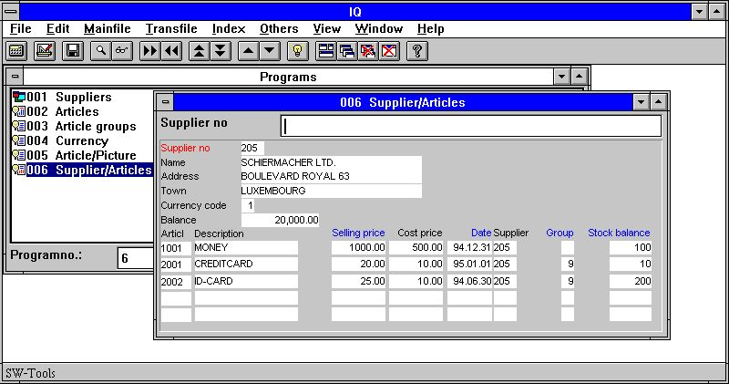

28. View of all articles for supplier 205
It is possible to make selections on the following fields displayed with a blue heading:
- Selling price (va#3)
- Date of last purchase (va#5)
- Group (va#7)
- Stock balance (va#8)
The selection is entered as a constant value and performed when pressing the [CURSOR DOWN] key.
If you want to cancel the selection and view all the transaction from the start once more, enter a blank followed by the [CURSOR DOWN] key.
IQ determines from the value you enters which selection should be performed. Entering 12,34 will select on amount, 12 selects on the code field. If amount only is present both will select on amount. Entering a text triggers the superindex search.
Depending on what you want to select the constant value must be entered according to the following rules on the selection fields:

4.7.1.1. Amount field
If required to select on the amount field you must enter the constant value as a numeric value with decimals. For example, you must enter
1000,00
followed by pressing the [CURSOR DOWN] key to select articles where the amount field (Selling price) equals the value 1000.
Normally the selection only retrieves transactions where the amount field equals the entered value. However, you may enter
> 1000,00
to retrieve transactions greater than 1000,00. You may of course use all of the following operators:

 | Operator | Description
 | = | equals
 | > | greater than
 | < | less than
 | >= | greater than or equal to
 | <= | less than or equal to
 | <> | not equal to

4.7.1.2. Date field
If required to select on the date field you must enter the constant value as a numeric value with 6 digits and being a valid date. For example, you must enter
010187
or
870101
in order to select transactions where the date field (Date of last purchase) is greater than or equal to the date 010187.

4.7.1.3. Code field
If required to select on the code field you must enter the constant value as a numeric value with maximum 4 digits. For example, you must enter
9
or
09
in order to select transactions where the code field (Article group) equals the value 9.

4.7.1.4. Refno. field
If required to select on the refno. field you must enter the constant value as a numeric value with more than 4 digits. For example, you must enter
00010
in order to select transactions where the refno. field (Stock balance) equals the value 10.

4.8. Sum of transactions
If the last field you select to display on a transaction line is an amount field (2 decimals) IQ will automatically generate a column adding up this amount.
The appropriate calculations for calculating the total in a free field (WW#21) and placing these on the display line using the first free field (WW#1) is generated. You may of course modify or remove this as required.

4.8.1. Brought forward amount
If the last field you select to display from the MAIN file is an amount field this will be used as a starting value for the sum of transactions instead of 0. This is also placed as a calculation which you can modify.

4.9. Multiple screen lines / transaction
When you edit the form layout of your query program you will just see the first transaction line layout, IQ duplicates this by itself the number of times needed.
Just place a transaction field on a new line to make each transaction split over more lines. You may also use the :1 option by defining the query, see this.

5. Saving, Deleting and documenting queries

Queries can be defined and used temporary or can be saved as programs so that it can be started later on without having to define the query once more.

5.1. Saving a query
The query can be saved when the query is active, by selecting the following function:

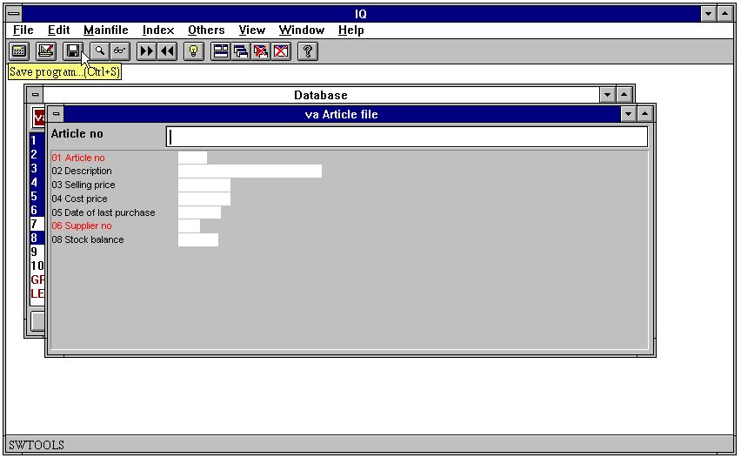

29. The save function
When the function is selected the following dialog appears:

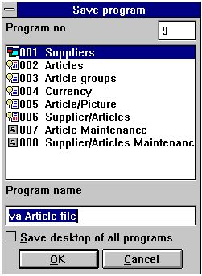

30. The save dialog

5.1.1. Program number
The program number can be selected from 1 to 999, allowing a maximum of 999 queries in one IQ system. If the selected program number already contains a defined query, the previously saved program will be overwritten.

5.1.2. Program name
The program name can be entered using any letters, digits, blanks and special characters. It is displayed in the IQ program overview and used as window title when the program has been started.

5.1.3. Save desktop of all programs
Normally one query is saved as one program. When the program is saved it also stores information about the position and size of the query form.
When working with more than one active query on screen, you would want to get the same queries active the next time IQ is used. For example, if the suppliers, articles, currency and article group queries are active, you would want to save all the queries as one program, to avoid having to start each and every program the next time.
By selecting this option IQ saves all active programs in one, and by starting this program the next time IQ defines or opens the queries saved.
For example, the program 1 - suppliers has been saved with this option marked, and opens the following queries when started:

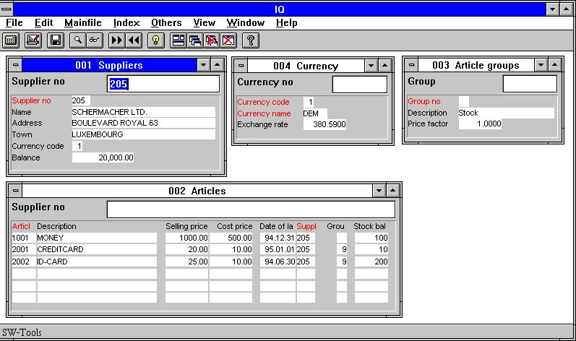

31. Multiple queries saved in one program

5.2. Deleting a query
Before a query can be deleted, the program has to be selected from the program overview. Then select the following function:

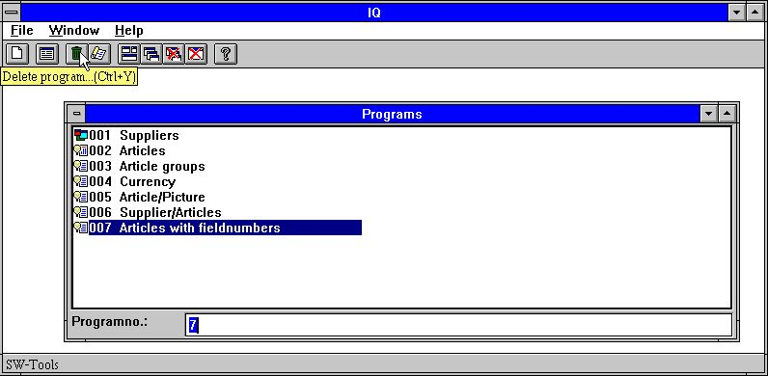

32. Deleting a query
When a program is deleted it cannot later be restored.

5.2.1. Amending a program without file access
When IQ cannot open all files properly you may continue after the error message by choosing Yes below:

33. Not all files could be opened in an IQ program

5.3. Printing program documentation
To print IQ program documentation select the following function:

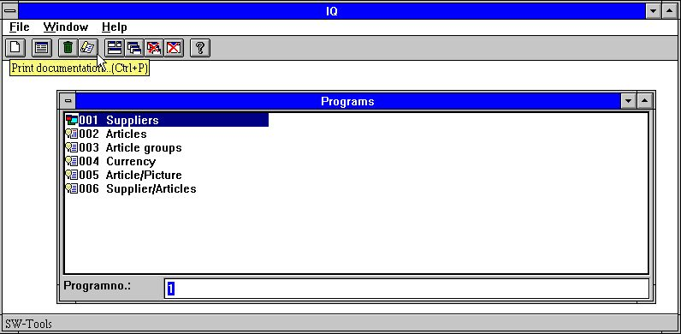

34. Documentation function
In this dialog you may select one or more programs to print documentation on. Use the left mouse button to click on the program to print or if selecting several programs, keep the [CONTROL] or [SHIFT] key pressed down while clicking on the programs:

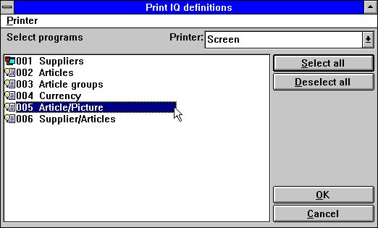

35. Selecting programs to print
The documentation of an IQ programs may look like this:

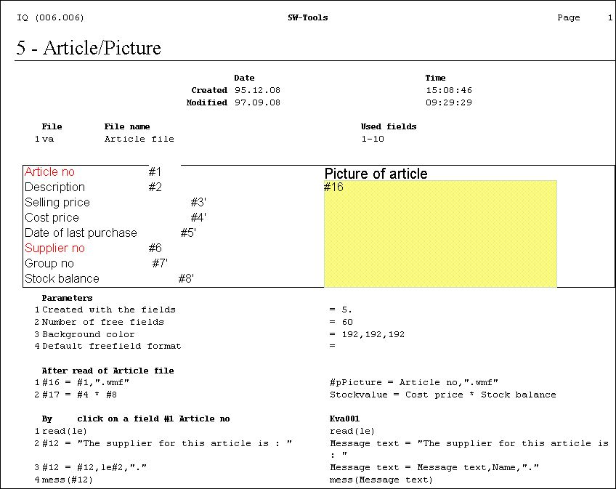

36. Example of IQ program documentation

5.4. Help and check on fields
In the VIEW menu you finds the possibilities to switch on more or less help display for the database fields on screen. When you are moving the mouse over a field with helptext and the help option is on this text will be displayed.

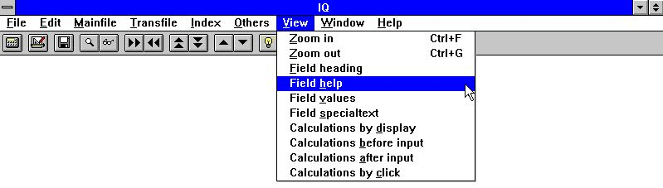

37. The VIEW menu

5.4.1. Field documentation
In the EDIT menu you will find a new entry point for writing documentation for each field on the screen.

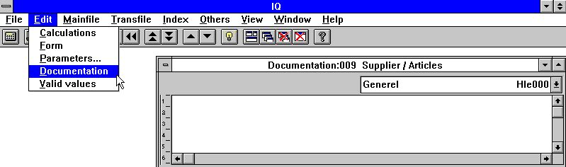

38. Field documentation
This enables you to document the workfields in a program just like a fixed database field or to extend the database documentation with specific points on this program.

5.4.2. Valid values
As with documentation you may define valid values on workfields also.

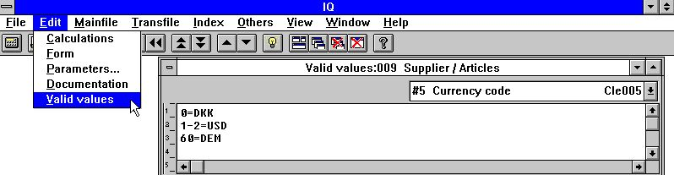

39. Valid values
You must follow the syntax: <values> = Text where values may be single values or ranges.

6. Program parameters

Before the parameters can be changed for a query, it has to be saved. If not saved IQ will ask to save before activating the function. Please refer to 'Saving queries'.
The dialog for program parameters contains the following:

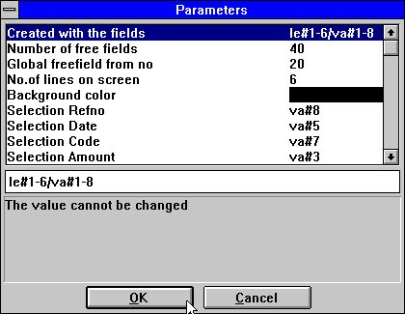

40. Program parameters

6.1. Created with the fields
The value displays the fields used to define the query program. It cannot be changed.

6.2. Number of free fields
Normally a programs has 40 free fields available. By changing this value you may increase the number of free fields to max. 499.

6.3. Global free field from number
Determines which free fields are common for all lines on a query and which are local to the single transaction. See 'calculations on transaction queries'.

6.4. Number of transaction lines on form
The value is used to control how many (transaction) lines to display on the query form. The standard value is 6.
The value is only available for queries that are defined on list form or with main and transaction tables.

6.5. Background colour
You may select a background colour specific for this program. The function activates the Windows standard colour selection dialog.

7. Amending form

Before the form can be amended for a query, it has to be saved. If not saved IQ will ask to save before activating the function. Please refer to 'Saving queries'.
A query allows amendment of the generated form. It is possible to insert and remove fields, add calculated free fields, insert pictures and much more.

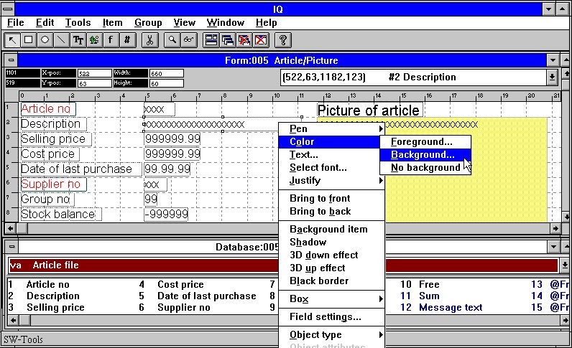

41. Amending the form

7.1. Inserting fields
By clicking on a field in the database window it is possible to insert a new field on the form:

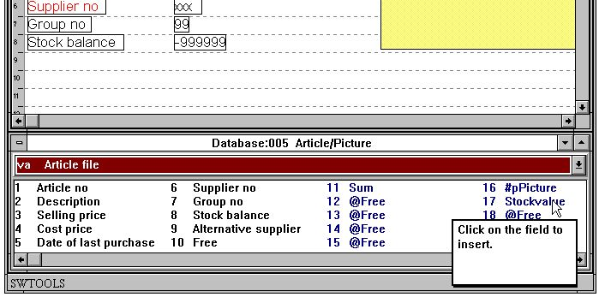

42. Selecting field to insert on form
When the field has been selected the layout window will automatically select the Database field function. It is now possible to insert the field:

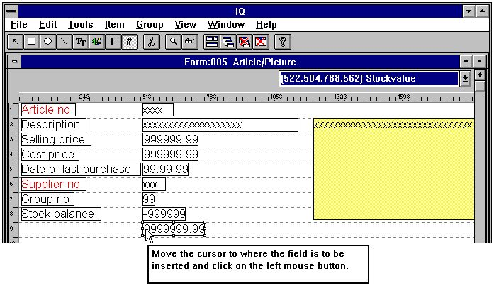

43. Inserting the field on the form

7.1.1. Insert with field heading
If the field heading is required it can be inserted along with the actual field. Double click on the field to insert will display the following dialog:

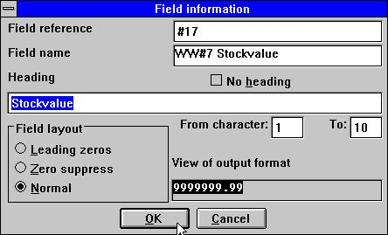

44. Selecting field with heading to insert on form
It is now possible to change the field heading or exclude it. It is also possible only to display a part of the field changing the from/to character position.
If the field is numeric you may select one of three options:
1. Leading zeroes
2. Zero suppress
3. Normal
The Normal option displays zero values as 0,00.

7.1.1.1. Part of fields and tablefields
Part of fields #5(2,13) and tablefields #7(2) may also be included directly in layout for an IQ program.

7.2. Inserting font specific text
To insert font specific text select the following function:

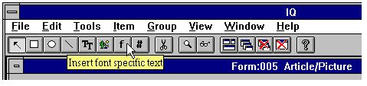

45. Selecting the font specific text function
Then move the cursor arrow to the point where the text is to be inserted and click on the left mouse button. The function will display the following dialog:

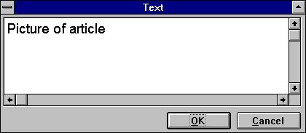

46. Dialog for font specific text
The text will then be inserted and the size of the element calculated according to the last used font. If the font is to be changed it can be done after insertion of the text by using the RIGHT mouse buttom and then selecting one of the following menu items:

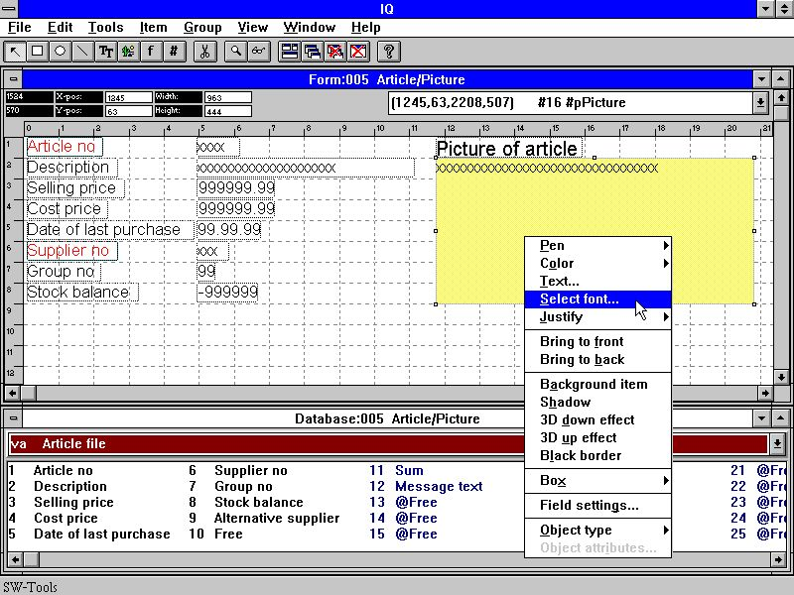

47. Function to change font of an element
The function activated is the Windows standard font selection dialog.

7.3. Drawing rectangles, circles, lines and pictures
Other drawing functions include rectangles, circles, lines, true type text and picture elements. The functions can be selected from the menu or the toolbar:

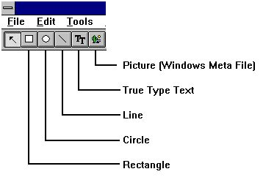

48. Toolbar buttons for draw functions
For example, to draw a rectangle click on the tool button for rectangle. Move the mouse arrow to the top- leftmost position and click on the left mouse button. While keeping the left mouse button pressed, move the arrow to the ending point of the rectangle and release the left mouse button. The element is now inserted and the style, colour etc. may be changed activating the right mouse button.
You may continue inserting draw elements of the selected type until the 'Change element or mark group' function is selected.

7.4. Deleting elements
To delete an element make sure the function 'Change element or mark group' is selected. Click on the element to delete or mark a group of elements. When the elements are selected press [Ctrl+Y] or click on the following button:

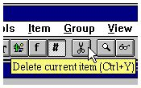

49. Deleting the current selected element or the marked group

7.5. Box sizing and field flags
The BOX entry may be used to size the field boxes automatically and the new FIELD SETTINGS may be used in DATAMASTER to control field input, see also the SETFLAG and CLRFLAG functions.

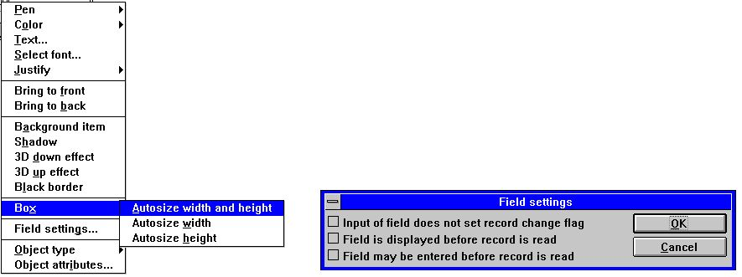

50. Edit Box size and Field settings

7.6. Changing colour, font and justification
Each element may have different colours, fonts etc. To amend the settings for each field or a group of fields first ensure the function 'Change element or mark group' is selected and press the right mouse button. It activates a floating menu with the following options:

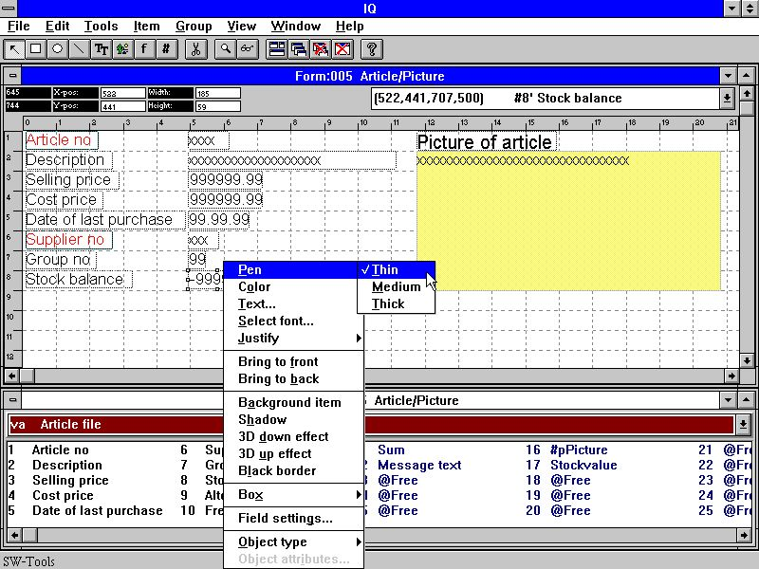

51. Changing colour, font and justification

7.6.1. Pen
The pen width is normally used for elements of type box, circle or line. It can be:
Thin (1 dot)
Medium (2 dots)
Thick (4 dots)

7.6.2. Colour
The colour of an element is divided in two categories:
Foreground and background colour
If no background colour is required please checkmark the menuitem
No background
When selecting to define the for- or background colour IQ will activate the Windows standard colour selection dialog.

7.6.3. Text
If the element contains text it is possible to edit the text using the function.

7.6.4. Font
When changing the font for an element IQ will activate the Windows standard font selection dialog. You may then select the font type, style, size etc.
Please note that the size of the element is not changed. This must be done manually after ending this function.

7.6.5. Justification
An element may be justified three ways
Left justified
Centred
Right justified
Normally numeric fields are right justified.

7.6.6. Bring to front / back
An IQ form supports display of field on top of each other. E.g. you may display field on top of a picture or drawn boxes and lines. If you select to bring an element to the top it is displayed on top of all other elements. If send to back all other elements are displayed on top of it.

7.7. Object type and attributes
You can control the field behaviour with the object type and attribute entries:

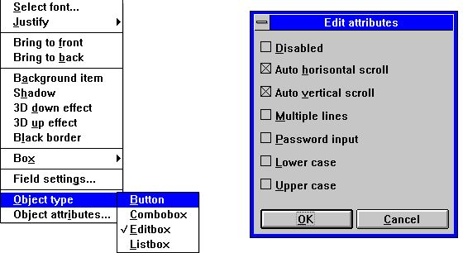

52. Object type and attributes

7.8. Moving, deleting and changing group of elements
If you need to move, delete or change a group of elements it can be done following these instructions:
Make sure the 'Change element or mark group' function is selected. Move the mouse arrow to the top-left position of the group of elements and click the left mouse button. Continue to hold the left mouse button down while moving the mouse arrow to the bottom-right position of the group. When the dotted rectangle marks the group of elements release the left mouse button.

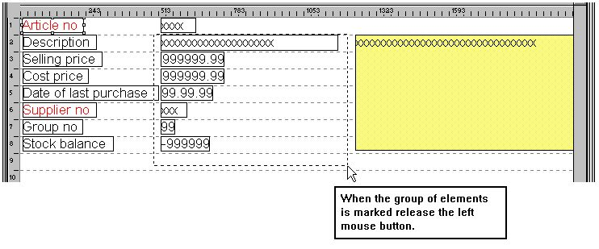

53. Marking a group of elements
The selected group is now marked.

7.8.1. Moving the group
Moving the group is done by pressing the left mouse button when the arrow is pointing to an element in the marked group. While moving the mouse the left mouse button must be held down. When released the group is moved.

7.8.2. Deleting the group
Select the delete function when the group has been marked.

7.8.3. Changing the group
When the group is marked you may perform the same action as described in 'Changing colour, font and justification' on a single element.

7.8.4. Blocks of lines
When lines are defined on a query the complete line block may now be moved or resized by dragging the markers in the left margin.

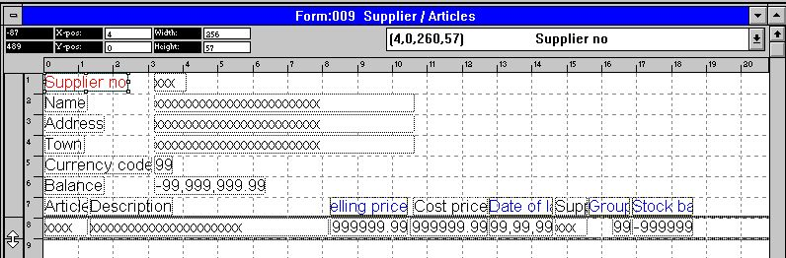

54. Editing the layout of a transaction query

8. Calculations

Before the calculations can be edited the query has to be saved. If not saved IQ will ask to save before activating the function. Please refer to 'Saving queries'.
With this function, you may calculate results which may or may not be displayed on the form. The syntax of calculations and installed subfunctions is described in the manual part 2 - CALCULATIONS AND SUBFUNCTIONS.

8.1. Edit calculations
When selecting this function the following screen is displayed:

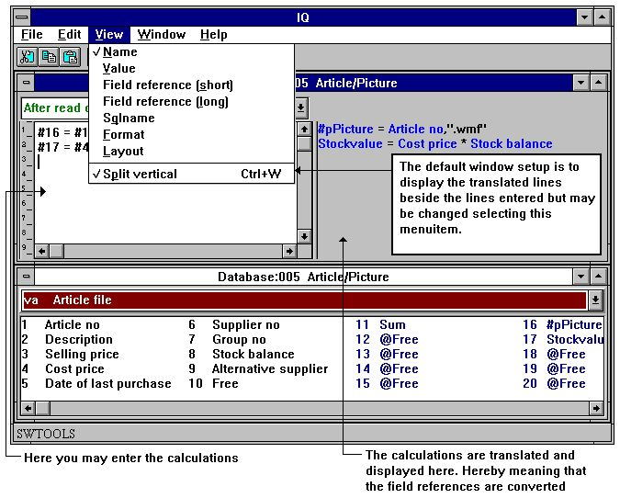

55. Calculations
In the 'Amend form' function, you have edited the form and have chosen to display a free field with a related format and name. If you make the query before you defined the calculation, you will get the value 0 in the field. You may enter, for example:
#17 = #8 * #4
This means that Fieldnumber 17 (Stockvalue) is to be calculated as
#8 (Stockbalance) * #4 (Costprice)

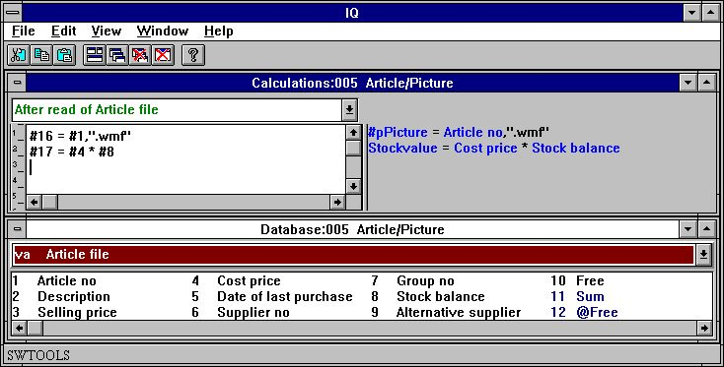

56. Refering to picture filename and calculating the Stockvalue
The example above shows how the field numbers used in calculations are translated into fieldnames, it is now easy to read the calculation of stock value. We will discuss the picture calculation below.
Now you may proceed with more calculations or close the calculation window and test the inquiry.

8.2. View of translated calculations
Normally the translated calculations are displayed in colours and all field references are translated into fieldnames.
In the calculations (and in the form layout) you may change the translation mode of fields as shown here:

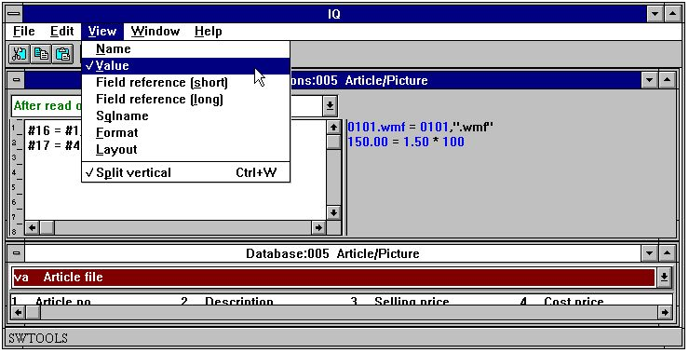

57. Changing view of translated calculations

8.3. Picture fields
You may define free fields for pictures. First you have to define the free field as an alphanumeric field to hold a physical filename equal to the picture filename.
So that IQ knows that the field is a picture field the name must be entered as:
#p<name>
where the #p defines the field as a picture field.
The field can then be inserted on the form and the field sized to fit the size of the picture.
To calculate the picture filename you can enter the following calculation:
#16 = #1,".wmf"
The free field 16 is then calculated as 'Article number' plus the extension
".wmf"
resulting in the picture filename 0101.wmf if the article number is 0101.
Please note that only 'Windows Meta File' (wmf) is supported in this version.

8.4. Functions
IQ has a number of built in functions for rounding, date calculations etc., which you can use in the calculations. Part 2 - CALCULATIONS AND SUBFUNCTIONS describes all these.

8.5. Entry points for calculations
IQ programs allows you to define calculations at different entry points in the standard program. The entry points are:
- After read of main table
- By click on a field
- By start of program
- By end of program
I the program is defined with main- and transaction table you may also define calculations at the following entry points:
- After read of transaction table
The entry points may be selected from the following combo-box:

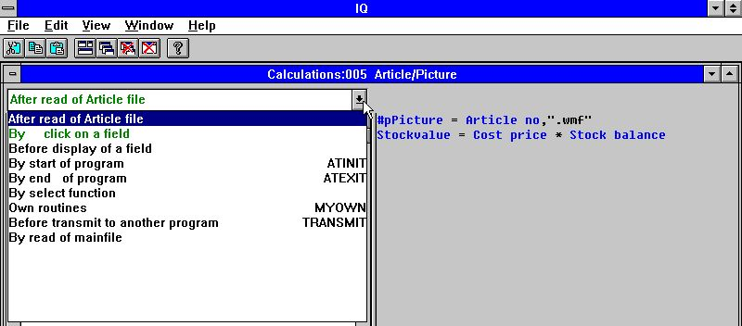

58. Entry points for calculations

8.5.1. After read of main table
The calculations are performed each time a record is read from the main table. This entry point could for example be used to calculate the Stockvalue in a free field if the main table is 'Articles'.

8.5.2. By click on a field
You may define calculations here that are only activated if the user clicks on the field.
When the entry point is selected another combo-box becomes available:

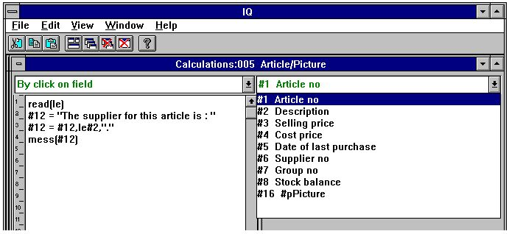

59. Field entry points for calculations
An example could be to display a message with the supplier name if the user clicks on the article number:

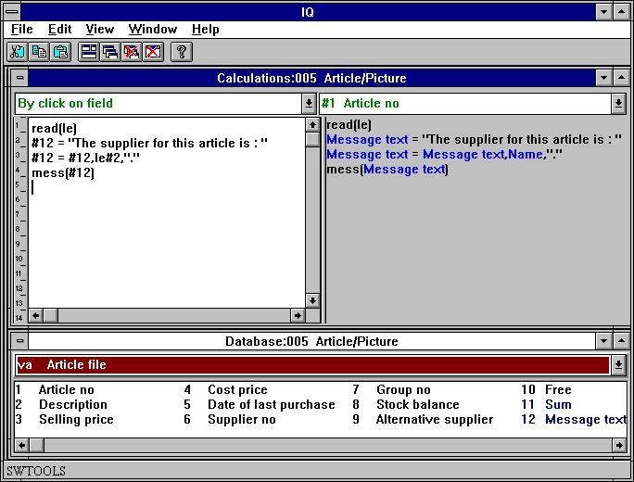

60. Calculations by click on a field
The result of the calculations is:

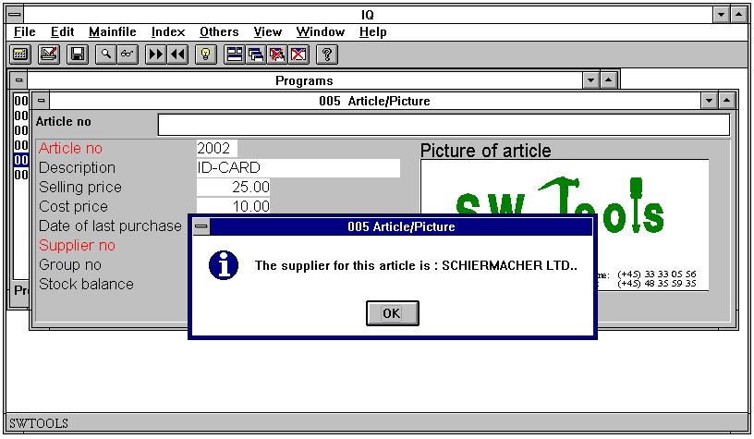

61. Result of calculations when click on field

8.5.3. By start of program
The calculations at this entry point will only be performed by start of the program.

8.5.4. By end of program
The calculations at this entry point will only be performed by end of the program.

8.5.5. After read of transaction table
The calculations are performed each time a record is read from the transaction table. This entry point could for example be used to calculate the Stockvalue in a free field if the main table is 'Supplier' and the transaction table 'Articles'.

8.5.6. Before DISPLAY of a field
The calculations placed here are carried out just before a field is displayed the first time.

8.5.7. OWN routines
A subroutine may be placed in any calculation area using first RETURN and then LABEL: calculations RETURN
The area of MYOWN calculations is just a good place for such common routines.

8.5.8. Before TRANSMIT to other programs
When this program decides to update other programs it will first call the before transmit calculations. Here you can read the programnumber which will be updated and information about this:
#IQSendto = This program number will be updated
#IQSendsub = The program is placed in this subsystem number
#IQSendfile = This is the ID of the programs mainfile
Update will carry on if you return 0 and will be skipped by a RETURN(-1)

8.5.9. By select of a FUNCTION
When a function is selected IQ will make the corresponding action to this. But before this is done you have the possibility to check if the function is allowed at the given place.

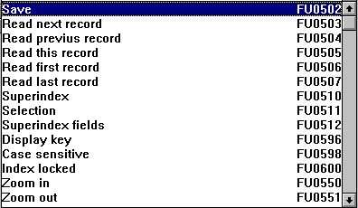

62. Function calculations
All the menu functions can be found here and you will note that the calculation LABEL is named as FUnnnn, nnnn being the function number as 551 for ZOOM OUT.

8.5.9.1. DOFUNCTION messages
What Windows does when a function is selected is to send a MESSAGE to the given program with the function number (e.g. 551 for ZOOM OUT) whereafter the program takes action on this.
With DOFUNCTION(551) you can send such a message yourself and this will be threaten exactly as if the user had activated the ZOOM OUT button.
You may even tell the DOFUNCTION to send the message to another active program and you may pass a key also, for example will
DOFUNCTION(505,#1,20)
ask program number 20 to read the record with the key given in field 1.

8.5.10. By read of mainfile
With these calculations you can influence the reading of the mainfile.

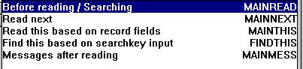

63. Mainfile calculations
Each of the calculations may set #OK and RETURN(-1) to tell the file is read. You may build your own searchroutine here but some programming knowledge would be required for this.

8.6. Transaction queries and free fields
Transaction queries works with a transaction buffer. When a transaction is read and the calculations performed the transaction is placed in the buffer together with any other table read with a connection to the transaction.
Only the number of transactions needed for the actual display are read and calculated and only once. Going forward/backward in the display will take the values from the buffer.
Also the result of the calculations for each line is placed in this buffer in form of free fields. The free fields acts as a separate table but are logically divided into two parts, one connected to the transaction file and so buffered and one connected to the main file and kept away from the buffer.
How many free fields are kept for each transaction is determined by the parameter 'GLOBAL FREE FIELD FROM' which as standard connects the first 20 free fields to the transactions and the rest to the main file.

8.6.1. Sum of transactions
The best way to illustrate how the free fields is used in a transaction query is to look at the sum made when defining a query like:
le#1-5/va#1-3
The sum is calculated in the first 'global' free field connected to the mainfile which becomes #27 (LE has 6 fields and first global free field is 6+21=27).
After reading of the main table the sum is initiated as brought-forward: #27=0
And for each transaction line the sum is added up with: #27=#27+va#3
We could stop here and then just display the field on the transaction line. This will work fine when just going forward in transactions but if you try to go to 'previous page' the sum becomes the same all over. The last calculated value is displayed for all transaction lines.
We needs something which 'sticks' to the single transaction line and that is exactly what the first free field (#7) is doing:
For each transaction line we set: #7=#27
and display field 7 instead of field 27 for each line. Now the result is buffered together with the transaction line and correct independent of how we move in the transactions.
You could say why is not all free fields kept in the buffer together with the single transactions. If you decide just to have on field displayed together with the main file fields as 'sum of transactions' this would then be dependent on which transaction was currently displayed on screen. We really need to have two separate types of free fields.

8.7. DEBUG in the calculations
As the number of possibilities to make calculations in IQ/DATAMASTER grows the possibility to make mistakes grows also.
You may now switch on a DEBUG window by placing a calculation line
DEBUG(1)
which when executed will open a debug window which shows like:

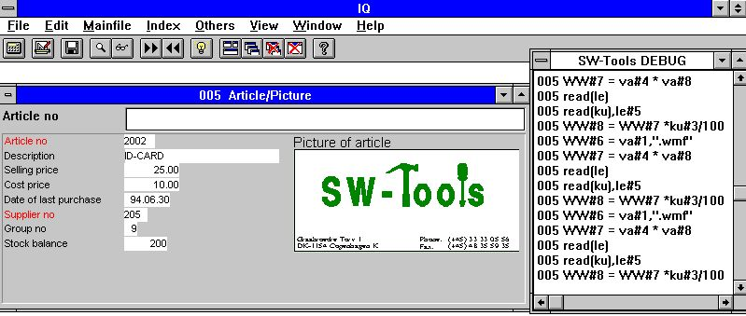

64. The DEBUG window
When opened the DEBUG window displays informations of all calculations being done in all programs. All sections of all open programs will be shown in this but any flow control such as IF...THEN will display only the expression itself.
The debug window remains open until you close IQ or a DEBUG(0) is met.

9. Interaction between queries

IQ provides interaction between queries, where a supplier query can update the view of an article list automatically based on the relation defined in the Data Dictionary between the supplier- and article table.
If you make a query on supplier number 205 in the supplier query:

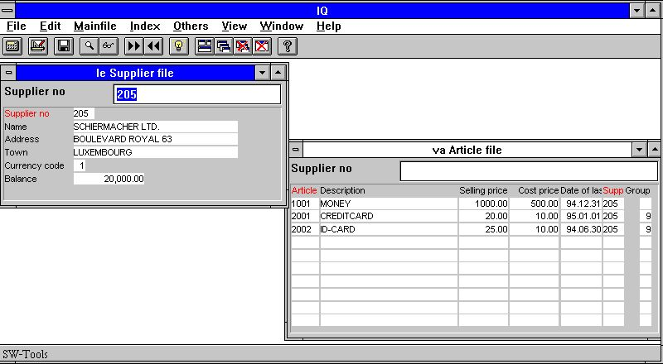

65. Query on supplier 205 automatically updates the article list
it will update the view of the article list query so that it displays the articles where the supplier equals 205.
You may control if the program should try to update other queries and if it should be updated itself if other queries changes its view. The control can be set individually in each program by marking or removing the following menu items in the menu 'Others':

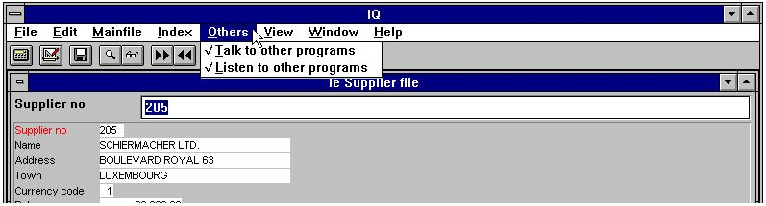

66. Control talk and listen mode

9.1. Talk to other programs
If the menuitem is check marked this query will try to update all other opened queries if a relation exists.

9.2. Listen to other programs
If the menuitem is check marked this query will be updated if another opened query changes its view and a relations exists between the queries.

9.3. Example of multiple queries
In the demo system you have a program 1 available. The program was saved with the desktop option when the programs 1 to 4 was active. Therefore, when starting this program IQ start 4 queries automatically.
By retrieving supplier number 205 IQ will update the view in the other three programs based on the relations defined in the Data Dictionary.

67. Demo program where one query updates the view of others
First it updates the article query, only displaying the articles where the supplier number matches. This is because the relation between the supplier table and the article table is supplier number.
Then IQ updates the article group query, because the article table has a relation to the article group table, and because the supplier query resulted in a changed article query. Due to the changed view in the article query this programs updates the article group query.
The last program updated is the currency query. It is updated because the supplier table has a relation to the currency table using the currency code field.

9.4. Interprogram communication
Above the DOFUNCTION could be used to send a message to another open program. This is one way of communicating between two programs.

9.4.1. Program number
In general functions using program number as parameter accepts one of the following:
<program> parameter for IQ functions may be given as 47 or 1047.
47 means first instance of the running program number 47 whereas
1047 means first instance of the running program number 47 in subsystem 1.
0 means current program number.

9.4.2. Fields from other programs
By use of the LET command you may read/modify variables in another program:
LET (20.#1-3=#1-3) Sets field 1-3 for program 20 = this program #1-3
LET (#1-3=20.#4-6) Sets field 1-3 in this program to #4-6 from program 20
LET (#10=#3.4) Sets field 10 equal to field 3 from line 4

9.4.3. GOSUB common subroutines
A label for GOSUB may be preceded by the program number as
GOSUB 20longjump
which causes the routine LONGJUMP in the open program 20 to be executed.

9.4.4. GLOBAL variables A1,A2,...
The Basic-like variables A1,A2,... you may use as global data for all programs as setting A1=#1 in one program and reading this value in another. Also A$,B$,... may be used.

9.5. DIALOG function for additional input
The DIALOG function enables the user to pop up dialogboxes with a selected set of fields at any point of a report execution or in an IQ program for example by click on a field.

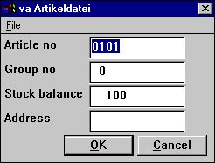

68. DIALOG("#1,7-8,le#3") in an article query
DIALOG("#1,7-8,le#3") defines a dialog with the given fields. The fields documentation is used if present as floating online help when the mouse cursor is moved over the leading text.
A number of options may be stated together with the fields such as C for Combobox, L for Listbox with valid values, W for field width and so on. These are described in the subfunction reference part of this manual. In fact are many of the new dialogs in TRIO made with the same function.

9.6. OLE 2.0 support
Support of OLE 2.0 Object Linking and Embedding gives the user possibility of integrating other Windows applications in the report or query defined in TRIO.
For example Microsoft Word may be used when defining a customer letter and a video sequence may be played on an article query.
The interface is simple to use as the OLE object is just defined as a field in TRIO marked as OLE and placed on the report form / IQ query just like a picturefield. Display and amendment of the contents will then be carried out by the selected OLE server program. Optionally a link to an existing document may be used or an object embedded and stored within the TRIO program can be created.
The TRIO OLE manual describes these functions in details.

10. Start parameters and standard programs

10.1. IQ Start parameters
IQ may be selected from WINDOWS using the following parameters:
IQWIN ssppp Start program ppp in subsystem ss
IQWIN -e EXIT IQ when the current program finishes
IQWIN -M... Restrict menu, see the MENUS function
IQWIN -D DATAMASTER maintenance programs may be defined
IQWIN -nl No Logo by start, Runtime only.
Programs cannot be defined or changed

10.2. Standard programs
In the standard subsystem (see RAPGEN) you will find the standards for the IQ and DATAMASTER programs. When a new program is made not only the layout but also the parameters and calculations are taken from here so any changes done to these are reflected in all new programs.

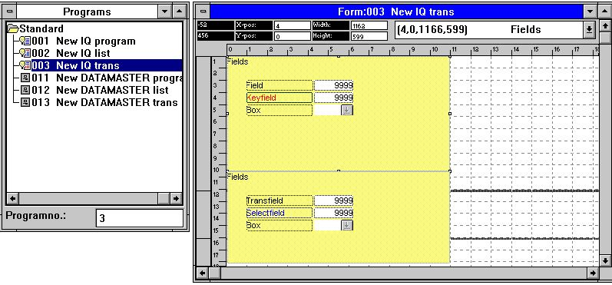

69. A standard program for IQ
In the layout for the transaction program above you note two blocks, one for the main file and one for the transactions. Both the attributes for the fields and their leading text may be changed.
Note that the DISTANCE between the fields defines the line distance in the new program.
NOTE: If you reinstall or upgrade TRIO the standard programs must be adjusted again !

Figure list
1. IQ 4
2. Licence screen 5
3. Accessing the functions using menus or the toolbar 6
4. The toolbar during a query 6
5. Generel menus and buttons 7
6. Hardcopy 8
7. Selecting table id 10
8. Table fields 11
9. Example of an article query 12
10. Generating the query 13
11. Query on one table 14
12. Query on list form 15
13. Relationship to other tables 16
14. Selecting fields from a related table 17
15. Query with relationship between tables 18
16. Query on main and transaction table 19
17. Query form with field numbers 23
18. Preferences 24
19. Next data record 30
20. Previous data record 31
21. Superindex search 35
22. The ESCAPE cursor 36
23. Function for superindex fields 37
24. Editing superindex fields 37
25. Normal article list query 38
26. Selection on selling price greater than 100 38
27. Result of query with selection 39
28. View of all articles for supplier 205 63
29. The save function 72
30. The save dialog 73
31. Multiple queries saved in one program 76
32. Deleting a query 77
33. Not all files could be opened in an IQ program 78
34. Documentation function 79
35. Selecting programs to print 79
36. Example of IQ program documentation 80
37. The VIEW menu 81
38. Field documentation 82
39. Valid values 83
40. Program parameters 84
41. Amending the form 90
42. Selecting field to insert on form 91
43. Inserting the field on the form 91
44. Selecting field with heading to insert on form 92
45. Selecting the font specific text function 94
46. Dialog for font specific text 94
47. Function to change font of an element 95
48. Toolbar buttons for draw functions 96
49. Deleting the current selected element or the marked group 97
50. Edit Box size and Field settings 98
51. Changing colour, font and justification 99
52. Object type and attributes 106
53. Marking a group of elements 107
54. Editing the layout of a transaction query 111
55. Calculations 113
56. Refering to picture filename and calculating the Stockvalue 114
57. Changing view of translated calculations 115
58. Entry points for calculations 118
59. Field entry points for calculations 120
60. Calculations by click on a field 121
61. Result of calculations when click on field 122
62. Function calculations 129
63. Mainfile calculations 131
64. The DEBUG window 134
65. Query on supplier 205 automatically updates the article list 135
66. Control talk and listen mode 135
67. Demo program where one query updates the view of others 138
68. DIALOG("#1,7-8,le#3") in an article query 144
69. A standard program for IQ 148

Index

A
AND 43;45;112;117
B
Background 27;89
C
Calculations 112;113;121;150
CALCULATIONS 45;112;117
D
Definition 21
Deleting 71;77;97;109;149
Dictionary 3;4;16;135;138
Division 19
Documentation 79;149
Drawing 96
F
Fieldnumber 113
Foreground 101
H
History 20
I
Interaction 135
J
Justification 104
L
Licence 5;149
M
Mainfile 38;131;150
O
ODBC 3
P
Preferences 24;149
Printing 79
S
Saving 48;71;72;84;90;112
Selection 38;40;41;42;44;62;149
Subfunctions 45
SUBFUNCTIONS 45;112;117
Superindex 35;37;61;149
T
Toolbar 96;149
Transfile 62
U
Update 128

