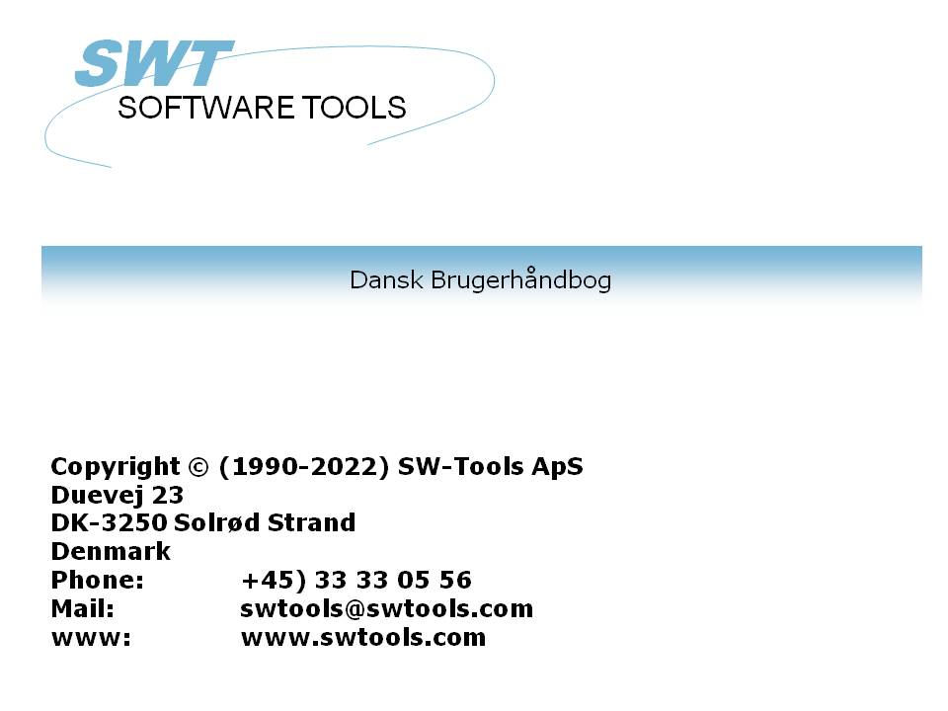

Global System Manager

22/11/01 / 2022-09-01 008.384

Contents
Contents 2
1. Support 3
2. Setup 4
2.1. Speedbase Meta Dictionary 5
2.2. Creating a new subsystem 6
2.3. Installing the driver for Speedbase 8
2.4. Speedbase interface adjustments 9
2.4.1. Initial changes to the interface 10
2.4.2. File system type 11
2.4.3. Database name 12
2.4.4. Searching for available Speedbase files 13
2.4.4.1. Searching single drives 14
2.4.5. Selection of database 15
2.4.6. Databases that exist on different locations 16
2.4.7. Databases with multiple data files 18
2.4.8. Different generation number for database and dictionary 19
3. Import of Global Dictionary to SW-Tools Dictionary 20
4. Record overview in the Data dictionary application 22
Figure list 24
Index 25

1. Support

Whilst this product is supported under the normal TIS Software terms and conditions, a sufficient level of knowledge in the importing applications is required. The Global support department will only deal with problems with the TRIO software, and do not provide support for the host products (Microsoft Excel etc.).

2. Setup

After TRIO and the ODBC driver have been installed you must setup the following:
- A Speedbase Meta Dictionary
- A subsystem containing the Data dictionary for Global
- A driver for the Speedbase file system
The setup is made using the 'Data Dictionary', which can be started from the program group SWTOOLS.

2.1. Speedbase Meta Dictionary
To enable the Data Dictionary to be utilised with Speedbase applications the disk labelled Speedbase Meta Dictionary must be installed as follows:
Boot into Global System Manager as normal, insert the Global format diskette into the drive, and using $F copy the meta dictionaries (designated by DBxxxxx, where x is the lower case name of the database in question, e.g. DBstock is the meta dictionary for DBSTOCK), into the data units that are to be used in conjunction with the ODBC driver.
If this is not done the Data Dictionary will not be able to access the Speedbase files.

2.2. Creating a new subsystem
The subsystem is created by selecting the following function from the menu 'File':

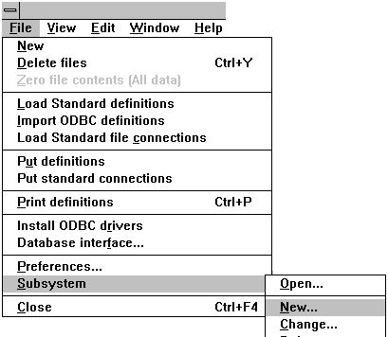

1. Creating a new subsystem
The most important information for the subsystem is the fields
- file definitions
- reports
These fields must be a path, local or on a network, where the data dictionary can be saved. If a non-existent path is entered it will automatically be created.

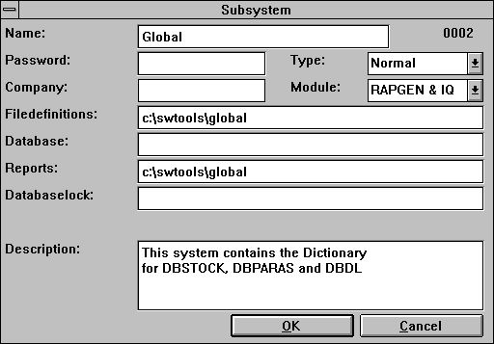

2. Important information on the subsystem
The field 'name' is used to give the system a logical and understandable name. The 'description' is free text. It will only be displayed when the mouse cursor is moved over the system name in the other TRIO applications. You may want to set up several subsystems for example one for live data and one for a test database.

2.3. Installing the driver for Speedbase
The driver may be installed using the application 'Data Dictionary'. The function to select is on the menu 'File':

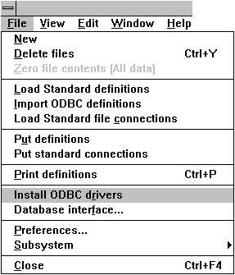

3. Installing the Speedbase driver
The file system for Speedbase is GSM - Global System Manager. Select it and click OK. The application will restart itself, and the Speedbase file system will be installed. However, it is necessary for the driver to know which database to access on which unit.

2.4. Speedbase interface adjustments
The database interface (driver) can be changed from the menu 'File' by selecting the function:

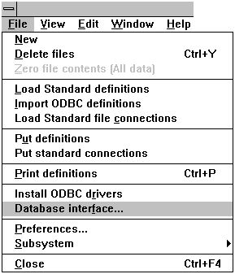

4. Changing the Speedbase interface
The function consists of a dialog window. This initially displays information on the driver type 'SSV Textfile'. To change the installed Speedbase interface, select the type 'GSM' from the first combo box.

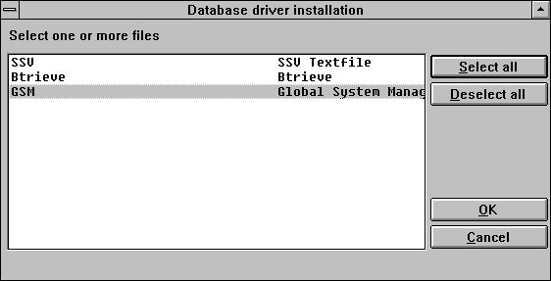

5. Selecting the driver for Speedbase

2.4.1. Initial changes to the interface
Start by changing the 'Description' to a logical and understandable name. This allows the interface to be installed multiple times for different databases in the Global system.
Set the 'Read only' to 'Yes.'. The driver only supports reading the Speedbase files - NO updates.

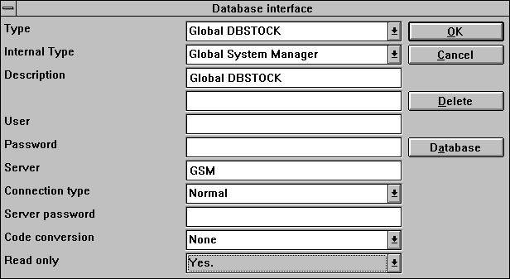

6. Initial interface changes
Now select the button 'Database'. This will activate a new dialog with the actual database information for the Global system.

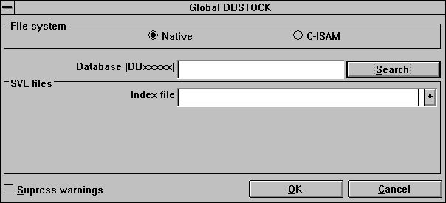

7. Initial interface changes

2.4.2. File system type
The Speedbase interface supports Native and C-ISAM file systems.

2.4.3. Database name
The database name must be entered as DBxxxxx, where xxxxx is the actual database name, e.g. STOCK. If it is not known what databases are available on the system, the 'Search' function may be used.

2.4.4. Searching for available Speedbase files
When the search function is activated it will start the search on the local drive C. If no databases are found on the drive a message box will be displayed. You can select 'Yes' to search all drives - local and network drives. If 'No' is selected the search on other drives may be performed later on.

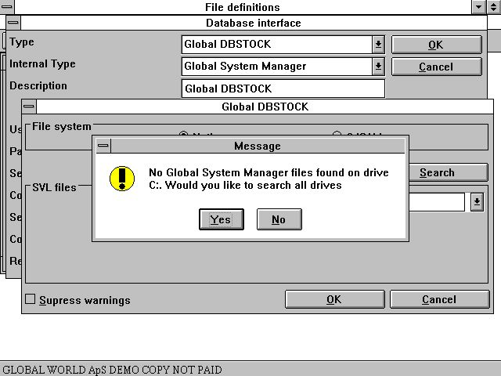

8. Searching for available databases

2.4.4.1. Searching single drives
In the next dialog it is possible search a single drive. The dialog contains a button 'Search' followed by a combo box to the right. This box displays all drives that have not been searched. By first selecting a drive (here D: is selected) and then 'Search' the system will perform the search on that drive only.

2.4.5. Selection of database
When the search has found one or more databases they will be listed:

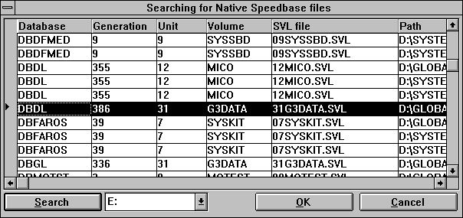

9. List of found databases
Select the database to access and confirm the selection by 'OK'.

2.4.6. Databases that exist on different locations
If the system has the same database in different locations the selection of a database may result in the following message:

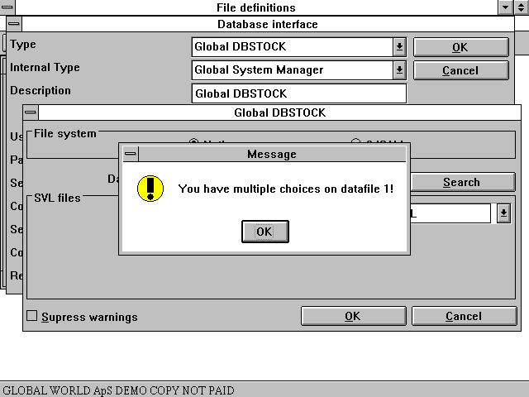

10. Same database on different locations
This is because the search module cannot determine which data file(s) belongs to which index file. The reason is the use of logical on network unit names such as STD, DLD, A32 etc.
For example this PC has two Global file systems installed in the following paths:
D:/Global
D:/SYSTEMS/TRIO/GSM81
If the database DBDL is selected from the D:/Global system the index file is found in the SVL file
D:/Global/GSM200/31G3DATA.SVL
which is equal to the physical unit 231 database DBDL.
The index file holds unit information for each data file used, which in this example is logical unit DLD for data file 1 DBDL 1 (3 spaces between DBDL and 1). The search routine has found the data file 1 for the database DLDL in the following locations:
D:/Global/GSM200/31G3DATA.SVL (unit 231)
D:/SYSTEMS/TRIO/GSM81/GSM200/31G3DATA.SVL (Unit 231)
Because it cannot determine which of the two SVL files to access, it will choose the best fit, that is the same SVL file as for the index file. If this is incorrect you can edit the path name used to correct it.

2.4.7. Databases with multiple data files
In the Speedbase file system a database consists of one index file
DBxxxxx
and one or more datafiles
DBxxxxx1 - Data file 1
DBxxxxx2 - Data file 2
DBxxxxx3 - Data file 3
Each datafile may be located in various units. For example, the index file may be located in unit 231 the data file 1 in unit 232 and the data file 2 in unit 231.

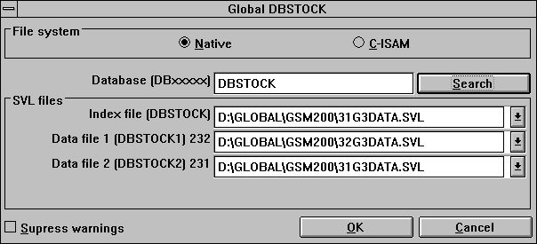

11. Databases with multiple data files

2.4.8. Different generation number for database and dictionary
If the system detects access to a database where the generation number for the database (index file) differs from the data dictionary a warning will be displayed as a messagebox each time a file is opened.
This warning may be suppressed with the checkmark on the installed driver

3. Import of Global Dictionary to SW-Tools Dictionary

The Global system has its own data dictionary for each database defined. This dictionary may be imported to the SW-Tools dictionary, but the Global system must contain a meta dictionary file whose name is
DBxxxxx (Database name in lower case)
on the same unit as the index file DBXXXXX (Database name in upper case).
The import may be performed from the following menu:

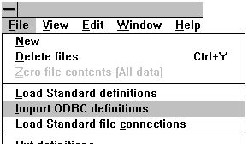

12. Importing data dictionary from Global system
Before the file descriptions for the database can be imported, the newly installed interface must be selected. This is done in the upper right corner where the function normally has the selection 'SSV Textfile'.

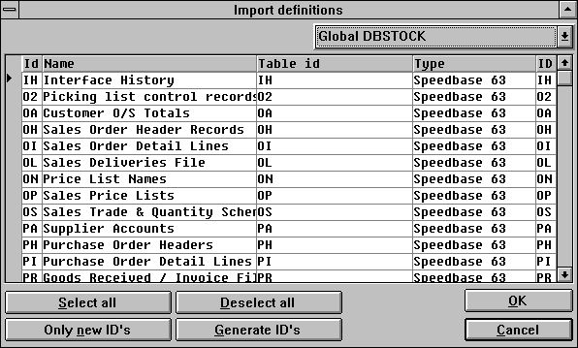

13. List of files in database
The files will be imported with the same file id's as known in the normal Global system, e.g. OH for Sales Order Header Records. The list also includes the database generation number as information in the column 'Type'.
By selecting 'OK' all file descriptions will be imported.

4. Record overview in the Data dictionary application

Before a record overview can be performed a file description must be selected.

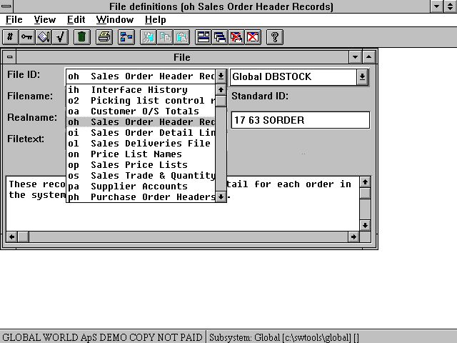

14. Selecting a imported file description
When the dictionary has been loaded you may select a record overview from the menu 'View'.
If there is a difference in the generation number between the database and the dictionary the following message will appear:

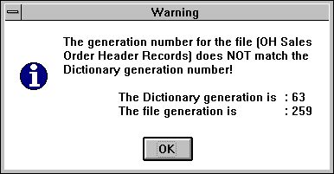

15. Selecting a imported file description
If not or when 'OK' selected for the message, a new window will be opened with an overview of the first 99 records for the selected file.

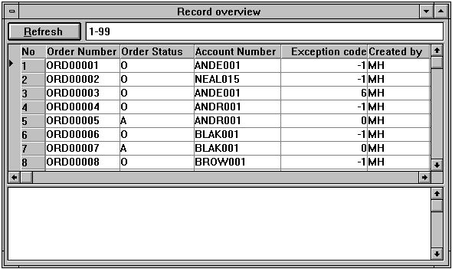

16. Record overview of Sales Order Header Records

Figure list
1. Creating a new subsystem 6
2. Important information on the subsystem 7
3. Installing the Speedbase driver 8
4. Changing the Speedbase interface 9
5. Selecting the driver for Speedbase 9
6. Initial interface changes 10
7. Initial interface changes 10
8. Searching for available databases 13
9. List of found databases 15
10. Same database on different locations 16
11. Databases with multiple data files 18
12. Importing data dictionary from Global system 20
13. List of files in database 20
14. Selecting a imported file description 22
15. Selecting a imported file description 23
16. Record overview of Sales Order Header Records 23

Index

D
Database 10;12;20
DBxxxxx 5;12;18;20
DBXXXXX 20
Dictionary 4;5;8;20
G
Global 1;3;4;5;8;10;16;20;21;24
GSM 8;9
O
ODBC 4;5
S
Setup 4
T
TRIO 3;4;7;16
U
Unit 16

